Chemistry and Biochemistry, PhD 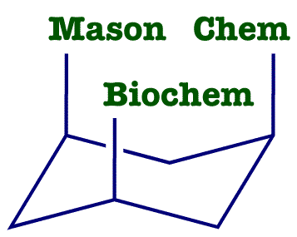
List of Courses for GMU Catalogs Fall 2013 and Later

Instructions

Use this List of Courses if you started the PhD in Chemistry and Biochemistry in Fall 2013 or later, or if you changed to the Fall 2013 university catalog. To find out what catalog Patriotweb believes you are on, do a Degree Evaluation on yourself in Patriotweb. In the screen which has your courses, your Catalog Year will be at the bottom.

Starting on page 2 is the List of Courses form for the PhD in Chemistry and Biochemistry. Please fill it out the form and e-mail it back to the Graduate Coordinator at cbgrad@gmu.edu.

Guidelines

For past courses, list the Semester and Grade. For present courses, list the Semester and leave the Grade blank. For your future courses, put them in the semesters you guess you will be taking them. This does not lock you in to those choices. Your schedule can be changed in a later semester.

Electives (39 credits) are lectures courses, CHEM 796, and CHEM 896. Put your CHEM 998 and 999 credits in Dissertation Research (24 credits). Do not put 796 and 896 credits in Dissertation Research (24 credits).
Chemistry and Biochemistry, PhD

Student’s Name G Number _

LIST OF COURSES

Core Courses (6 credits) | Cr Hrs | Institution | Semester | Grade
CHEM 833 – Phys. Chem. and Biochem. | 3
CHEM 817 – Organic Structural Spectroscopy | 3
Seminar (3 credits)
Electives (39 credits)
Dissertation Research (24 credits)

