Chemistry and Biochemistry, PhD 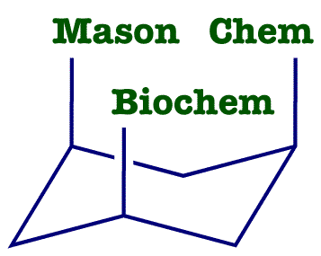
List of Courses for GMU Catalogs Prior to Fall 2013

Instructions

Use this List of Courses if you started the PhD in Chemistry and Biochemistry before Fall 2013 and you are not changing to the Fall 2013 university catalog. To find out what catalog Patriotweb believes you are on, do a Degree Evaluation on yourself in Patriotweb. In the screen which has your courses, your Catalog Year will be at the bottom.

Starting on page 2 is the List of Courses form for the PhD in Chemistry and Biochemistry. Please fill it out the form and e-mail it back to the Graduate Coordinator at cbgrad@gmu.edu.

Guidelines

For past courses, list the Semester and Grade. For present courses, list the Semester and leave the Grade blank. For your future courses, put them in the semesters you guess you will be taking them. This does not lock you in to those choices. Your schedule can be changed in a later semester.

Electives (24 credits) are lectures courses, CHEM 796, and CHEM 896. Put your CHEM 998 and 999 credits in Dissertation Research (24 credits). Do not put 796 and 896 credits in Dissertation Research (24 credits).
Chemistry and Biochemistry, PhD

Student’s Name G Number _

LIST OF COURSES

Core Courses (12 credits) | Cr Hrs | Institution | Semester | Grade
CHEM 814 - Advanced Bioorganic Chemistry | 3 | GMU | Fall 2011 | A
CHEM 821 - Theory of Analytical Processes | 3 | GMU
CHEM 833 - Physical Chemistry and Biochemistry | 3 | GMU
CHEM 891 - Doctoral Scientific Critique, Writing and Presentation | 3 | GMU
Research Emphasis Courses (9 credits)
 | 3 | GMU
 | 3 | GMU
 | 3 | GMU
Seminar (3 credits)
CHEM 790 - Graduate Seminar | 1 | GMU
CHEM 790 - Graduate Seminar | 1 | GMU
CHEM 790 - Graduate Seminar | 1 | GMU
Electives (24 credits)
 |  | GMU
 |  | GMU
 |  | GMU
 |  | GMU
 |  | GMU
 |  | GMU
 |  | GMU
 |  | GMU
Dissertation Research (24 credits)
 |  | GMU
 |  | GMU
 |  | GMU
 |  | GMU

