INSTRUCTIONS FOR SETTING UP A ZOOM MEETING REGISTRATION LINK TO USE ON THE ESP DEFENSE/PRESENTATION ANNOUNCEMENT TEMPLATES

For a PhD Dissertation Proposal Defense/PhD Dissertation Defense/MS Thesis Defense/

MS Project Presentation

If your defense/presentation includes a Virtual session, please note that sharing Zoom links on public websites or listservs is no longer recommended for security reasons. Instead, the defending student’s Advisor will set up a Zoom registration. This will automatically provide the registrant with an email containing the Zoom link. Neither the Advisor nor the student will have to respond to multiple email requests for the link.   
  
Full instructions from the Zoom website support can be found here:  
<https://support.zoom.com/hc/en/article?id=zm_kb&sysparm_article=KB0065026#h_01EDCWZHDR8ATR2ZC7ARGV9H3Z>

Quick Guide:

1. After you have logged into your GMU Zoom account, please click on “Schedule” next to your profile picture
2. On the next screen, please fill out the meeting details and make sure the “Required” is selected for Registration and “Generate Automatically” button is selected for Meeting ID.

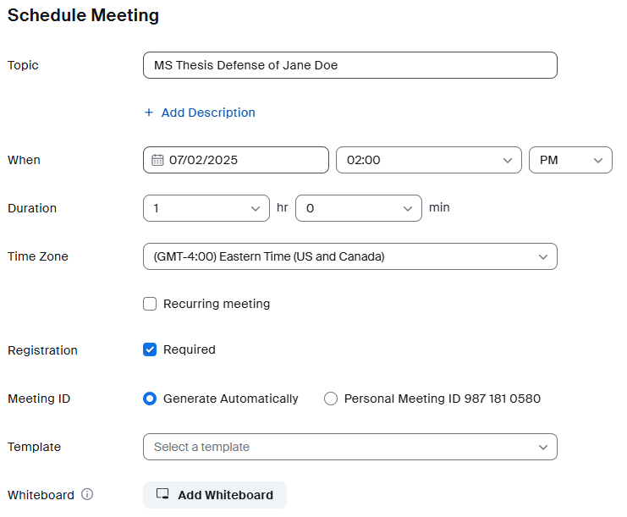

1. Continue to specify your Meeting settings (recommended settings selected in the screenshots above).

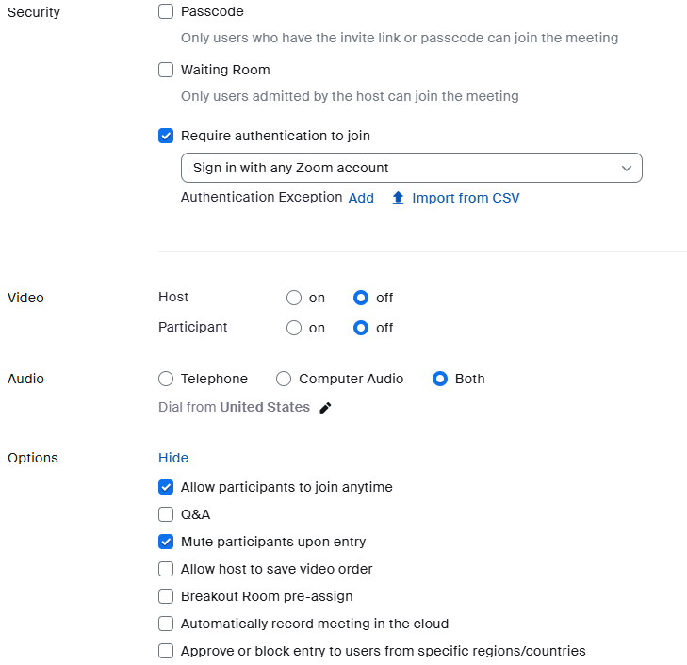

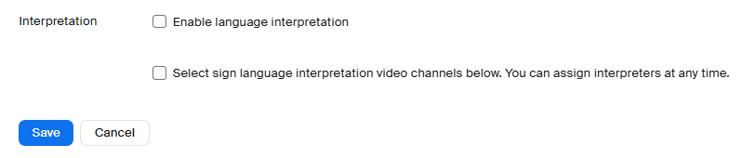

1. Click the blue Save button in the lower left corner.
2. Next screen will show your scheduled meeting information.

Information under the Details tab should look like this:

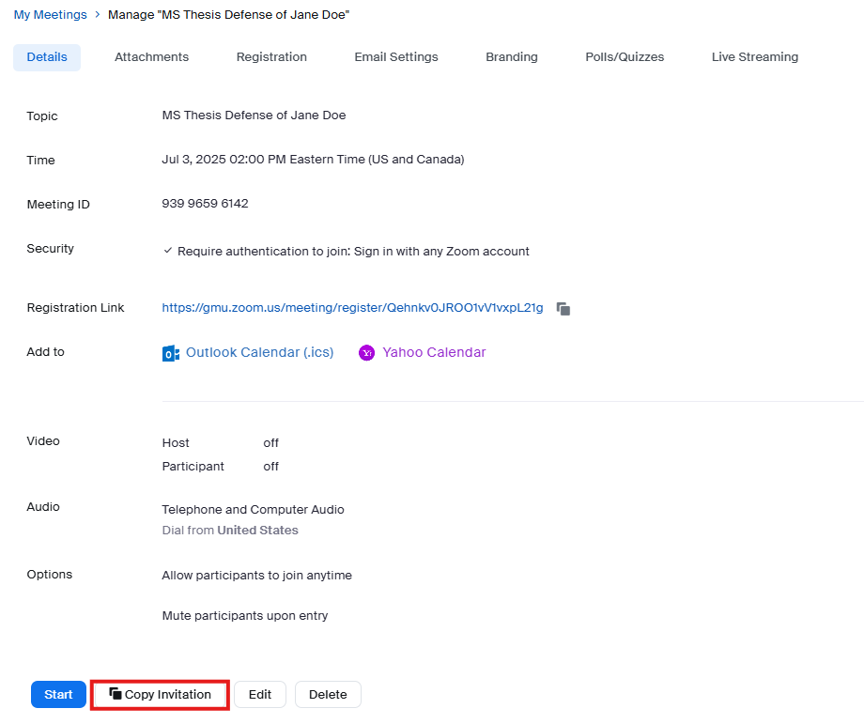

Information under the “Registration” tab should look like this:

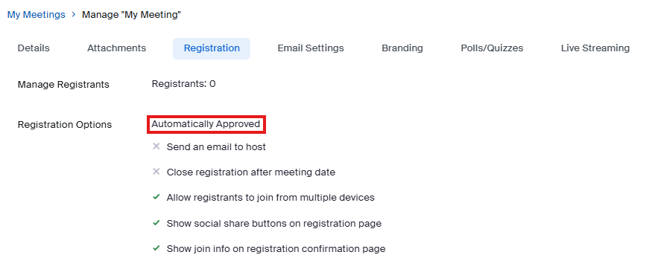

Information under the “Email Settings” tab should look like this:

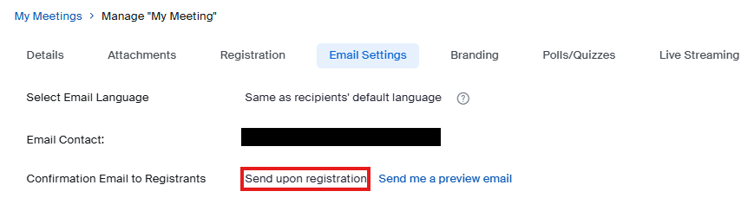

1. After clicking on “Copy Invitation” you should see the screen below. Copy and paste the **link to your meeting** into your ESP abstract template.

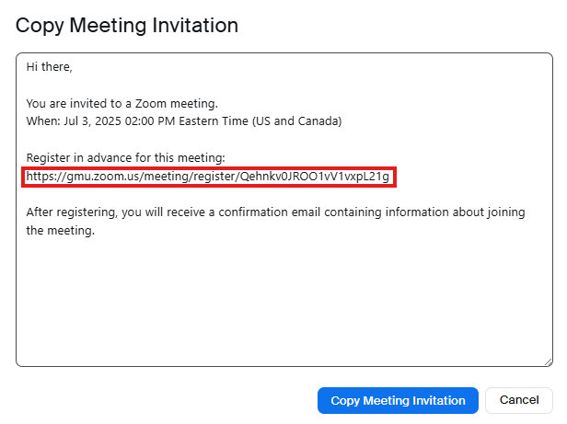

1. Your abstract template should look like this before sending it to the ESP Graduate Office for announcement and distribution:

[DEFENSE/PRESENTATION]

Department of Environmental Science and Policy

College of Science

George Mason University

**Candidate:** [Enter text without boldface]

**Defense/Presentation Date and Time:** [Enter text without boldface]

**Defense/Presentation Location:** [Enter text without boldface for the location, and add “and Virtual on Zoom”]

Register in advance to join by Zoom here:   
https://gmu.zoom.us/meeting/register/Qehnkv0JROO1vV1vxpL21g EXAMPLE from step 6

After registering, you will receive a confirmation email containing information about joining the meeting.

**Title:** [Enter text without boldface]

**Project Director:** [Enter text without boldface]

**Committee:** [Enter text without boldface]

**ABSTRACT**

[Limit 100 words. Delete all bracketed notes before submitting.]