GGS 579 - Remote Sensing – 12305 - 001

Syllabus

Instructor: Dr. Ron Resmini

Course description and objective: GGS 579, Remote Sensing, will provide graduate students with the concepts, principles, and methods of earth remote sensing. This course examines the use of various types and combinations of electromagnetic energy to obtain spatial and compositional information. Course content concentrates on: 1) nonphotographic, airborne, and spaceborne remote sensing concepts, systems, and sensors; and 2) essential operational parameters for existing and future systems and strategies for visual and digital extraction of features and information. The objective of this course is to provide graduate students with in-depth knowledge of the concepts, theories, principles, technologies, and methods of earth remote sensing and remote sensing data analysis.

Credit hours: 3

- Introductory Concepts
Energy Sources
Energy Interactions
Remote Sensing Systems and Data
- Photographic and Photogrammetric Principles (very brief overview)
Film-Based Imaging, Cameras
Filters
Electronic Imaging
Geometric Characteristics of Photographs
- Image Analysis and Interpretation
Fundamentals
- Digital Image Processing
Image Enhancement and Manipulation
Information Extraction
- Remote Sensing Systems/Hardware; Airborne and Satellite
NASA, ESA
Airborne and Spaceborne
- Multispectral Remote Sensing/Thermal Imaging
Physical principles
Algorithms
Applications
- Hyperspectral Remote Sensing
Physical principles
Algorithms
Applications
- Microwave and Lidar Sensing
Physical principles, data, and applications

Additional Information

- Two Textbooks:
Remote Sensing Principles, Interpretation, and Applications, 4th edition, 2020,
by Sabins and Ellis, Waveland Press, Inc., publ. (primary)

Remote Sensing and Image Interpretation, 7th edition, 2015,
by Lillesand, Kiefer, and Chipman, John Wiley & Sons, publ. (secondary; I suggest renting an electronic version)

- Class meeting:
Thursday, 4:30 p.m. to 7:10 p.m., in-person, face-to-face in Exploratory Hall 2310
- Office hours:
Thursday, 3:30 p.m. to 4:30 p.m., in-person, Exploratory Hall 2208 or by appointment
- Contact information:
Dr. Ron Resmini: rresmini@gmu.edu; v: 703-470-3022 (voice and text)

- Assignments:
Approximately weekly

- Software:
ENVI v6.x (the vendor, NV5, provides a student license; also, you have access to this software in Exploratory Hall 2310. I will say more about ENVI at the first class meeting.)

- Exams:
One midterm exam (date: 26 March 2026); open notes, open book, open internet, etc.
One final exam (date: 7 May 2026); open notes, open book; open internet, cumulative

- Grading:
60% homework assignments
20% midterm exam
20% final exam

- Grading Policy:
Grading in GGS 579 will follow university policy

From the online GMU University Catalog:
https://catalog.gmu.edu/policies/academic/grading/#text

Scroll down to: ‘AP.3.2 Graduate Grading’ and see the following:

Grade Quality Points Graduate Courses
A+ 4.00 Satisfactory/Passing
A 4.00 Satisfactory/Passing
A- 3.67 Satisfactory/Passing
B+ 3.33 Satisfactory/Passing
B 3.00 Satisfactory/Passing
B- 2.67 Satisfactory/Passing
C 2.00 Unsatisfactory/Passing
F 0.00 Unsatisfactory/Failing

* “Although a B- is a satisfactory grade for a course, students must maintain a 3.00 average in their degree program and present a 3.00 GPA on the courses listed on the graduation application.”

For this class, letter grades are based on the following numerical score ranges:

A+ ≥ 97.0 to 100.0
A ≥ 93.0 to < 97.0
A- ≥ 90.1 to < 93.0
B+ ≥ 83.3 to < 89.9
B ≥ 76.7 to < 83.3
B- ≥ 70.1 to < 76.7
C ≥ 60 to < 70.1
F <= 59.9

- A few important websites (there are many, many others!):
USGS EarthExplorer: https://earthexplorer.usgs.gov/
NASA Earth Observatory: https://www.earthobservatory.nasa.gov/
NASA Earth Science Enterprise: https://science.nasa.gov/earth-science/
NASA GSFC Landsat programs: https://landsat.gsfc.nasa.gov/
USGS Landsat Program: https://www.usgs.gov/landsat-missions/landsat-9
EROS Data Center: https://www.usgs.gov/centers/eros
ASPRS homepage: https://www.asprs.org/

- A few important journals (there are many others, too):

Remote Sensing of Environment (RSE)
ASPRS Photogrammetric Engineering & Remote Sensing (PE&RS)
IEEE Transactions on Geosciences and Remote Sensing (IEEE TGARS)
International Journal of Remote Sensing (IJRS)

- Schedule and textbook reading assignments (the schedule and assigned readings may change):

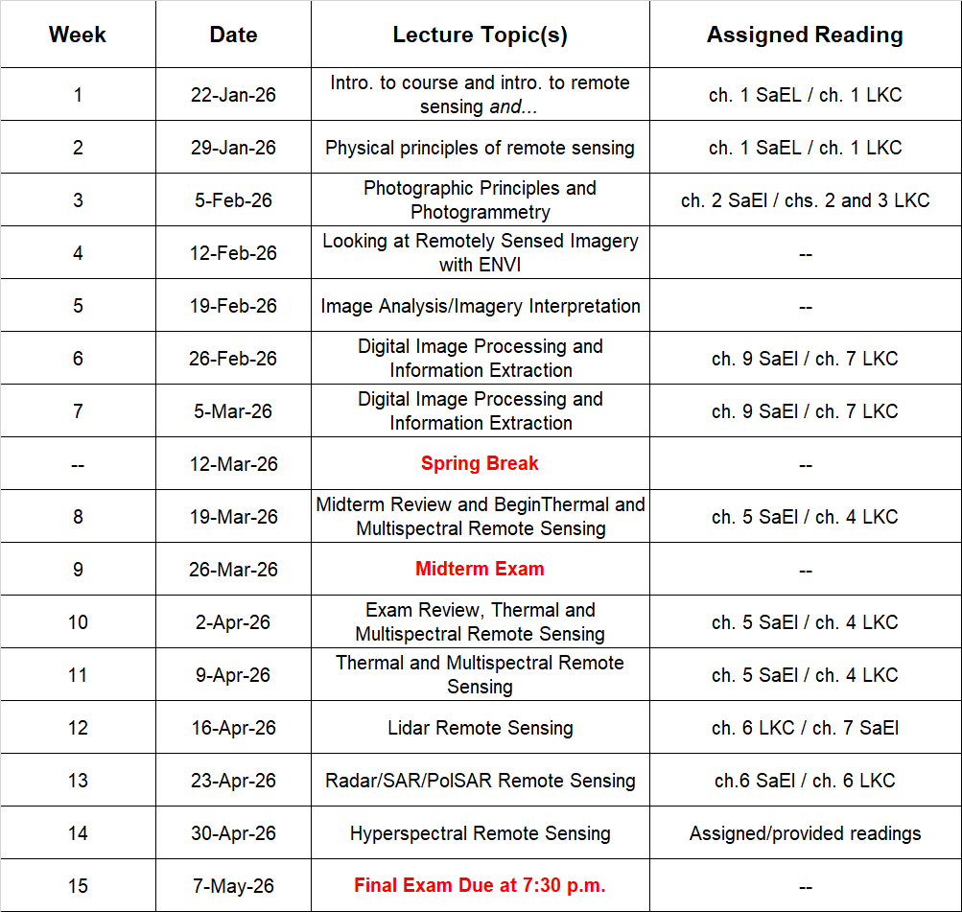

See also: https://registrar.gmu.edu/calendars/spring_2026/

Taken entirely from: https://ctl.utexas.edu/chatgpt-and-generative-ai-tools-sample-syllabus-policy-statements (and with several modifications):

"In this course, students shall give credit to AI tools whenever used, even if only to generate ideas rather than usable text or illustrations. When using AI tools on assignments, add an appendix showing (a) the entire exchange, highlighting the most relevant sections; (b) a description of precisely which AI tools were used (e.g., Gemini Pro 4 private subscription or DALL-E free version), (c) an explanation of how the AI tools were used (e.g., to generate ideas, turns of phrase, elements of text, long stretches of text, lines of argument, pieces of evidence, maps of the conceptual territory, illustrations of key concepts); (d) an account of why AI tools were used (e.g., to save time; to assist with data acquisition and processing; to help understand difficult technical concepts; to “chat” with scientific papers, to clarify writing, to experiment for fun). Overall, AI tools should be used wisely and reflectively with an aim to deepen understanding of subject matter.”

Academic Standards Code: Students are expected to review and abide by the GMU Academic Standards Code available at: https://academicstandards.gmu.edu/academic-standards-code/.

Students with disabilities: Disability Services at George Mason University is committed to providing equitable access to learning opportunities for all students by upholding the laws that ensure equal treatment of people with disabilities. If you are seeking accommodations for this class, please first visit http://ds.gmu.edu/ for detailed information about the Disability Services registration process. Then please discuss your approved accommodations with me. Disability Services is located in Student Union Building I (SUB I), Suite 2500. Email:ods@gmu.edu | Phone: (703) 993-2474.

Our commitment to non-discrimination: All will abide by the GMU non-discrimination policy available at: https://universitypolicy.gmu.edu/policies/non-discrimination-policy/.

Students who become ill: Students that become ill should follow the Mason health recommendations. See: https://shs.gmu.edu/.

University policies: Students must follow all university policies. See the University Policies website at http://universitypolicy.gmu.edu/.

Responsible use of computing: Students must follow the university policy for Responsible Use of Computing. See the university’s computing policies website at http://universitypolicy.gmu.edu/policies/responsible-use-of-computing/.

University catalog: Students should use the current university catalog at http://catalog.gmu.edu/.

University libraries: GMU’s libraries provide excellent resources for books and journals. There are also resources for distance students. See the library website at http://library.gmu.edu/distance/.

Writing center: The GMU Writing Center staff provides a variety of resources and services (e.g., tutoring, workshops, writing guides, handbooks) intended to support students as they work to construct and share knowledge through writing. See the Writing Center’s website at http://writingcenter.gmu.edu/.

Counseling and Psychological Services: GMU’s Counseling and Psychological Services (CAPS) staff consists of professional counseling and clinical psychologists, social workers, and counselors who offer a wide range of services (e.g., individual and group counseling, workshops, and outreach programs) to enhance students' personal experience and academic performance. See the Counseling and Psychological Services website at http://caps.gmu.edu/.

Family Educational Rights and Privacy Act (FERPA): The Family Educational Rights and Privacy Act of 1974 (FERPA), also known as the "Buckley Amendment," is a federal law that gives protection to student educational records and provides students with certain rights. See the Registrar’s Office website at http://registrar.gmu.edu/privacy/.

Student support services at GMU: For a complete list of student support services available to you, see: https://stearnscenter.gmu.edu/knowledge-center/knowing-mason-students/student-support-resources-on-campus/.

Taken entirely from: https://stearnscenter.gmu.edu/home/gmu-common-course-policies/

Common Policies Affecting All Courses at George Mason University
Updated August 2025
These four policies affect students in all courses at George Mason University. This Course Policy Addendum must be made available to students in all courses (see Catalog Policy AP.2.5).
Additional policies affecting this course, and additional resources or guidance regarding these policies, may be provided to students by the instructor.

Academic Standards
Academic Standards exist to promote authentic scholarship, support the institution’s goal of maintaining high standards of academic excellence, and encourage continued ethical behavior of faculty and students to cultivate an educational community which values integrity and produces graduates who carry this commitment forward into professional practice.
As members of the George Mason University community, we are committed to fostering an environment of trust, respect, and scholarly excellence. Our academic standards are the foundation of this commitment, guiding our behavior and interactions within this academic community. The practices for implementing these standards adapt to modern practices, disciplinary contexts, and technological advancements. Our standards are embodied in our courses, policies, and scholarship, and are upheld in the following principles:
- Honesty: Providing accurate information in all academic endeavors, including communications, assignments, and examinations.
- Acknowledgement: Giving proper credit for all contributions to one’s work. This involves the use of accurate citations and references for any ideas, words, or materials created by others in the style appropriate to the discipline. It also includes acknowledging shared authorship in group projects, co-authored pieces, and project reports.
- Uniqueness of Work: Ensuring that all submitted work is the result of one’s own effort and is original, including free from self-plagiarism. This principle extends to written assignments, code, presentations, exams, and all other forms of academic work.
Violations of these standards—including but not limited to plagiarism, fabrication, and cheating—are taken seriously and will be addressed in accordance with university policies. The process for reporting, investigating, and adjudicating violations is outlined in the university’s procedures. Consequences of violations may include academic sanctions, disciplinary actions, and other measures necessary to uphold the integrity of our academic community.
The principles outlined in these academic standards reflect our collective commitment to upholding the highest standards of honesty, acknowledgement, and uniqueness of work. By adhering to these principles, we ensure the continued excellence and integrity of George Mason University’s academic community.
Student responsibility: Students are responsible for understanding how these general expectations regarding academic standards apply to each course, assignment, or exam they participate in; students should ask their instructor for clarification on any aspect that is not clear to them.

Accommodations for Students with Disabilities
Disability Services at George Mason University is committed to upholding the letter and spirit of the laws that ensure equal treatment of people with disabilities. Under the administration of University Life, Disability Services implements and coordinates reasonable accommodations and disability-related services that afford equal access to university programs and activities. Students can begin the registration process with Disability Services at any time during their enrollment at George Mason University. If you are seeking accommodations, please visit https://ds.gmu.edu/ for detailed information about the Disability Services registration process. Disability Services is located in Student Union Building I (SUB I), Suite 2500. Email: ods@gmu.edu. Phone: (703) 993-2474.
Student responsibility: Students are responsible for registering with Disability Services and communicating about their approved accommodations with their instructor in advance of any relevant class meeting, assignment, or exam.

FERPA and Use of GMU Email Addresses for Course Communication
The Family Educational Rights and Privacy Act (FERPA) governs the disclosure of education records for eligible students and is an essential aspect of any course. Students must use their GMU email account to receive important University information, including communications related to this class. Instructors will not respond to messages sent from or send messages regarding course content to a non-GMU email address.
Student responsibility: Students are responsible for checking their GMU email regularly for course-related information, and/or ensuring that GMU email messages are forwarded to an account they do check.

Title IX Resources and Required Reporting
As a part of George Mason University’s commitment to providing a safe and non-discriminatory learning, living, and working environment for all members of the University community, the University does not discriminate on the basis of sex or gender in any of its education or employment programs and activities. Accordingly, all non-confidential employees, including your faculty member, have a legal requirement to report to the Title IX Coordinator, all relevant details obtained directly or indirectly about any incident of Prohibited Conduct (such as sexual harassment, sexual assault, gender-based stalking, dating/domestic violence). Upon notifying the Title IX Coordinator of possible Prohibited Conduct, the Title IX Coordinator will assess the report and determine if outreach is required. If outreach is required, the individual the report is about (the “Complainant”) will receive a communication, likely in the form of an email, offering that person the option to meet with a representative of the Title IX office.
For more information about non-confidential employees, resources, and Prohibited Conduct, please see University Policy 1202: Sexual and Gender-Based Misconduct and Other Forms of Interpersonal Violence. Questions regarding Title IX can be directed to the Title IX Coordinator via email to TitleIX@gmu.edu, by phone at 703-993-8730, or in person on the Fairfax campus in Aquia 373.
Student opportunity: If you prefer to speak to someone confidentially, please contact one of Mason’s confidential employees in Student Support and Advocacy (SSAC), Counseling and Psychological Services (CAPS), Student Health Services (SHS), and/or the Office of the University Ombudsperson.

