Plan of Study for Climate PhD & MS
Spring 2024
Natalie Burls [Director] and Barry Klinger [Graduate Coordinator]

Table of Contents
Overview 1
Climate Science Master’s Program 2
Climate Science Master’s Requirements (33 credits) 3
Climate Science Master’s Sample Schedule 4
Climate Science Master’s Program Plan of Study 5
Climate Dynamics Doctoral Program 6
Climate Dynamics Doctoral Program Requirements (72 credits) 7
Climate Dynamics Doctoral Program Sample Schedule 8
Climate Dynamics Doctoral Program Plan of Study 9
Climate Science Electives 10

Overview

There are several forms that you will need to submit as you progress through your degree. This is not one of them.

But please do use this document to ensure, in consultation with your advisor and the graduate coordinator, that you create a study plan to meet the requirements of your degree in a timely manner.

Climate Science Master’s Program

First review the catalog requirements for your chosen Climate Science MS concentration as well as our webpage describing the MS Program Path. Some MS students may wish to continue to the PhD. Admission of MS students into the Climate Dynamics doctoral program is not automatic, but MS students who wish to continue should consult with their advisor and the Graduate Coordinator, see our "MS and PhD" page.

Secondly, please review the course repetition plan on our syllabus webpage to see when the department plans to offer classes. Note this is just a plan and could be subject to change due to enrollment, faculty availability, etc.

Lastly, draft your plan of study in consultation with your advisor and the Graduate Coordinator using the “plan of study” table below. Note that the first table below provides a standard example of the classes typically taken semester by semester which you can use as a starting point and modify based on your specific situation. The “plan of study” table below is in the format of the Program of Study form that PhD students typically submit when they advance to candidacy, so although less relevant to the MS degree it may one day be useful.

It is the student’s responsibility to ensure that all paperwork related to their degree is submitted to cosgrad@gmu.edu / the registrar in a timely manner.

Climate Science Master’s Requirements (33 credits)

Catalog information has been summarized here for your convenience but please double check that the information in this file is consistent with the information in the relevant catalog year. The catalog information takes precedence.

https://catalog.gmu.edu/colleges-schools/science/atmospheric-oceanic-earth-sciences/climate-science-ms/#requirementstext

Core Courses for Masters (3 Credits, 15 Total)
CLIM 511 Atmospheric Dynamics 1 or CLIM 711 Intro Atmospheric Dynamics
CLIM 512 Physical Oceanography 1 or CLIM 712 Phys. & Dyn. Oceanography
CLIM 610 Introduction to the Physical Climate System
CLIM 614 Land-Climate Interactions
CLIM 690 Scientific Basis of Climate Change

Seminar/Reading (3 Credits Total)
CLIM 991 Climate Dynamics Seminar
CLIM 796 Directed Reading and Research
CLIM 996 Doctoral Reading and Research
(At least 1 cr from this group must be CLIM 991).

Thesis or Non-thesis Options (3 Credits Total)
Choose one of the following options:
Thesis Option: CLIM 799 Master's Thesis in Climate
Non-thesis Option: Choose one unrestricted, graduate-level elective course

Concentration in Climate Modeling (CM; 3 Credits Each, 12 Total)
CLIM 670 Earth System Modeling (odd years only)
CLIM 715 Numerical Methods for Climate Modeling (even years only)
CLIM 751 Predictability and Prediction of Weather and Climate
???? ??? 1 Elective (see list of approved courses)
OR
Concentration in Climate Data (CD; 3 Credits Each, 12 Total)
CLIM 680 Climate Data 3cr
CLIM 762 Statistical Methods in Climate Research
???? ??? 2 Electives from Mathematical, Computational, or Geographical elective list

Climate Science Master’s Sample Schedule
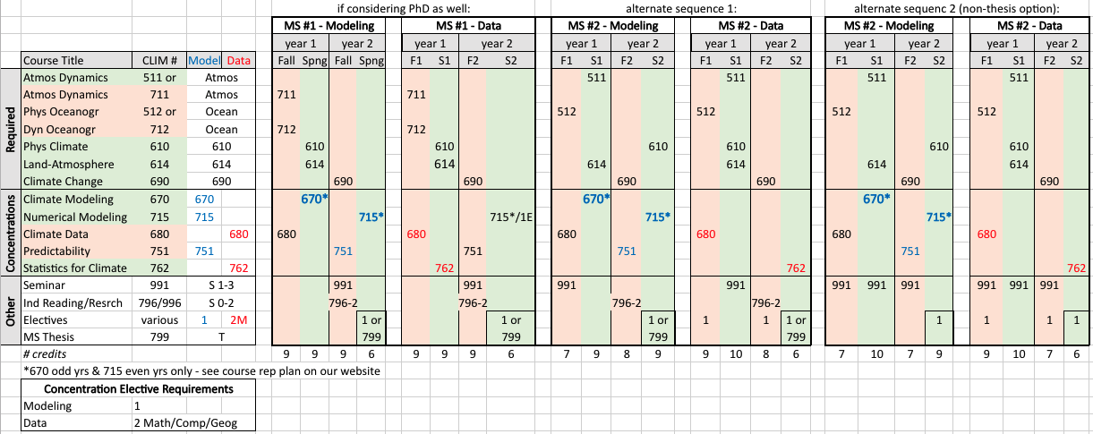
For a given scenario (considering PhD or alternate), differences in course schedule between 2 concentrations shown in bold, large font; courses taken to fulfill requirements specific to a concentration are shown in blue for modeling and red for data.

Background color of course represents semester course usually taught:
Fall | Spring | Either

Some courses are only offered every other year, including most electives (see Climate Science MS Electives) and the following:
CLIM 670 – odd years only (2023, 2025, etc.)
CLIM 715 – even years only (2022, 2024, etc.)

Climate Science Master’s Program Plan of Study

Student Name |  | G# |  | Email

Class (Short Title) | Credits | Institution (if not GMU) | Semester | Grade
Required Climate Science Classes (15 cr)
CLIM 610 Physical Climate
CLIM 614 Land-Atmosphere
CLIM 511 /711 Atmospheric Dynamics
CLIM 512 / 712 Dynamical Oceanography
CLIM 690 Scientific Basis of Climate Change
Required Concentration Classes (12 cr)
Seminar (3 cr)
CLIM 991 (1 cr)
CLIM 796/996/991 (2 cr total)
Thesis or Non-thesis Options (3 cr)
CLIM 799 or elective

Climate Dynamics Doctoral Program

If you have not already obtained an MS degree, we highly recommend that PhD students dual enroll in the Climate Science MS during their first semester in the PhD program (instructions under the “Add an MS degree to a PhD degree” section at the bottom of our "MS and PhD" page). If you have already received an MS and plan to apply for a reduction of PhD elective credits using comparable course work that you did during your MS, then dual enrolling in the MS degree might not be ideal if you plan to apply more than 6cr of previous MS course work.

First, review the catalog requirements for the Climate Dynamics PhD and/or your chosen Climate Science MS concentration as well as our webpage describing the PhD Program Path.

Secondly, please review the course repetition plan on our syllabus webpage to see when the department plans to offer classes. Note this plan is subject to change, but is the best estimate of future course schedules.

Lastly, draft your plan of study in consultation with your advisor and the graduate coordinator using the “plan of study” table below. Note that the first table below provides a standard example of the classes typically taken semester by semester which you can use as a starting point and modify based on your specific situation. The “plan of study” table below it is in the format of the Program of Study form that you will need to submit when you advance to candidacy.

PhD GRA contracts are typically drafted with
Year 1 |  | Year 2 |  | Year 3 |  | Year 4 |  | Year 5
Fall | Spring | Fall | Spring | Fall | Spring | Fall | Spring | Fall | Spring
9cr | 10cr | 10cr | 9cr | 9cr | 6cr | 7cr | 6cr | 6cr | 1cr
You can change the credits you take in a given semester, but if so please alert the program director and AOES HR specialist before June of the coming academic year so that they can draw up your GRA/GTA contract for the coming academic year accordingly.

It is the student’s responsibility to ensure that all paper work related to their degree is submitted in a timely manner. For students entering the PhD program with an MS that may want to transfer credits (aka reduction of credit) we recommend that they process the paperwork required for this during their first semester of the program. Please add any transferred credits to your plan of study below.

Climate Dynamics Doctoral Program Requirements (72 credits)

Catalog information has been summarized here for your convenience but please double check that the information in this file is consistent with the information in the relevant catalog year. The catalog information takes precedence.

https://catalog.gmu.edu/colleges-schools/science/atmospheric-oceanic-earth-sciences/climate-dynamics-phd/#requirementstext

PHD Core Classes (3 credits each, 15 total):
CLIM 610 Introduction to the Physical Climate System
CLIM 614 Land-Climate Interactions
CLIM 711 Introduction to Atmospheric Dynamics
CLIM 712 Physical and Dynamical Oceanography
CLIM 751 Predictability and Prediction of Weather and Climate

Core Computational Classes (3 credits each, 9 total):
CLIM 680 Climate Data (or CSI 690 Numerical Methods)
CLIM 715 Numerical Methods for Climate Modeling *Only offered spring even years
CLIM 762 Statistical Methods in Climate Research

Climate Seminar (1 credit each, 3 total)
CLIM 991 Climate Dynamics Seminar (taken three times)

Climate Qualifier: 997 (3 credits total)

Electives (3 credits each [except as noted], 21 total):
Graduate level electives, including CLIM courses and other relevant courses as approved by the graduate coordinator. Includes up to 6 credits of CLIM 796 or CLIM 996 (1-6 credits per semester).

Dissertation Research and Defense (Total 21 Credits):
Choose credits for the following courses in consultation with an advisor:
CLIM 998 Doctoral Dissertation Proposal
CLIM 999 Doctoral Dissertation (minimum 3 credits)

Climate Dynamics Doctoral Program Sample Schedule
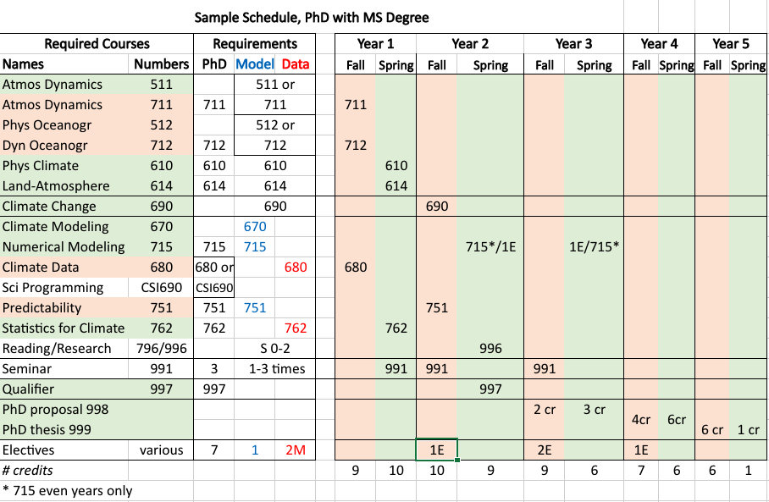
Background color of course represents semester course usually taught:
Fall | Spring | Either

Student typically starts CLIM 998 in 3rd year and continues CLIM 998 till Advancement to Candidacy, after which student enrolls in CLIM 999 each semester till completion of doctoral program. Once all credit requirements are met the student registers for full time equivalency to take 1 cr in last semester (form).

Some courses are only offered every other year, including most electives (see Climate Electives) and the following:
CLIM 670 – odd years only (2023, 2025, etc.)
CLIM 715 – even years only (2022, 2024, etc.)

Climate Dynamics Doctoral Program Plan of Study

Student Name |  | G# |  | Email

Class (Short Title) | Credits | Institution (if not GMU) | Semester | Grade
Required Climate Science Classes (15 cr)
CLIM 610 Physical Climate
CLIM 614 Land-Atmosphere
CLIM 711 Atmospheric Dynamics
CLIM 712 Dynamical Oceanography
CLIM 751 Predictability & Prediction
Required Core Computational Classes (9 cr)
CLIM 680 Climate Data or
CSI 690 Numerical Methods
CLIM 715 Numerical Methods Climate Modeling
CLIM 762 Statistical Methods in Climate
Electives (21 cr)
Seminar (3 cr)
Qualifier (3 cr)
Dissertation (21 cr)

Climate Electives

Climate Science
CLIM 631 | Urban Climate
CLIM 680 | Climate Data
CLIM 690 | Scientific Basis of Climate Change
CLIM 713 | Atmosphere-Ocean Interactions
CLIM 750 | Geophysical Fluid Dynamics
CLIM 751 | Predictability and Prediction of Weather and Climate
CLIM 752 | Ocean General Circulation
CLIM 753 | General Circulation of the Atmosphere
CLIM 754 | Elements of the Tropical Climate System
CLIM 759 | Topics in Climate Dynamics (when the topic is "Advanced Predictability" or "Convection") ²
GEOL 532 | Paleoclimatology
GEOL 535 | Quantitative Stratigraphy
GEOL 565 | Paleoceanography
GGS 670 | Introduction to Atmosphere and Weather
Mathematical, Computational, or Geographical
CLIM 715 | Numerical Methods for Climate Modeling
CLIM 759 | Topics in Climate Dynamics (when the topic is "Earth System Modeling") ²
CLIM 762 | Statistical Methods in Climate Research
CLIM 763 | Advanced Statistical Methods in Climate Research
GEOL 525 | Modeling Earth Signals and Systems
GEOL 553 | Field Mapping Techniques
CDS 501 | Scientific Information and Data Visualization
CSI 501 | Introduction to Scientific Programming
CSI 690 | Numerical Methods
GGS 553 | Geographic Information Systems
GGS 563 | Advanced Geographic Information Systems
GGS 650 | Introduction to GIS Algorithms and Programming
GGS 680 | Earth Image Processing
GGS 692 | Web-based Geographic Information Systems
PHYS 510 | Computational Physics I
Climate-Relevant
GEOL 506 | Soil Science
GEOL 513 | Hydrogeology
GEOL 563 | Coastal Morphology and Processes
BIOL 650 | Environment Analysis and Modeling
CDS 502 | Introduction to Scientific Data and Databases
CSI 600 | Quantitative Foundations for Computational Sciences
EVPP 506 | Science of the Environment I
EVPP 507 | Science of the Environment II
EVPP 529 | Environmental Science Communication
EVPP 542 | Urban Ecosystems Processes
EVPP 543 | Tropical Ecosystems
EVPP 550 | Waterscape Ecology and Management
EVPP 607 | Fundamentals of Ecology
EVPP 637 | Human Dimensions of Climate Change (when the topic is "Climate Change Policy & Politics" or "Climate Change, Public Administration, and Management")
GGS 507 | Geographic Approaches for Sustainable Development
GGS 531 | Land-Use Modeling Techniques and Applications
GGS 550 | Geospatial Science Fundamentals
GGS 579 | Remote Sensing
GGS 656 | The Hydrosphere
PHYS 660 | Space Weather
AIT 580 | Analytics: Big Data to Information
AIT 582 | Metadata Analytics for Big Data
COMM 660 | Climate Change and Sustainability Communication Campaigns
CS 504 | Principles of Data Management and Mining
PUBP 710 | Topics in Public Policy (when the topic is "Climate Policy & Politics" or "Climate Change, Public Administration and Management")

² | CLIM 759 Topics in Climate Dynamics is a special topics course in which different sections can address different subjects.

