Seminar in Neuroscience: Model Organisms in Neuroscience Research
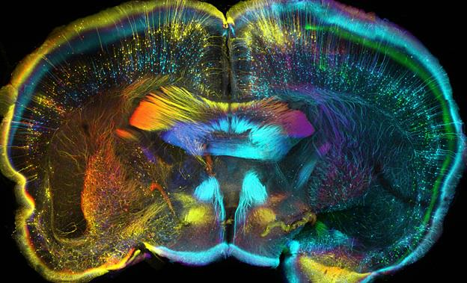
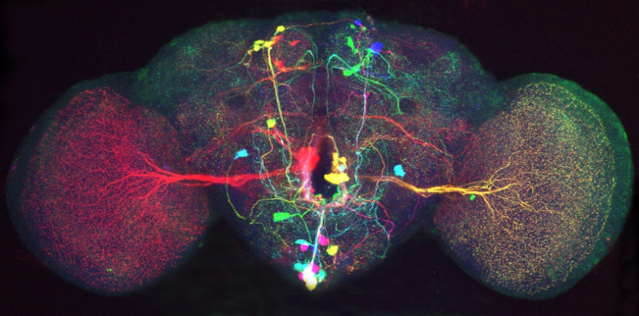
NEUR 411: Fall 2023

Instructor: Dr. Ren Guerriero (they/them)
Their email: lguerrie@gmu.edu
Their phone #: 703-993-5901
Meeting times: Thursday 1:30 – 4:10 pm
Meeting location: Innovation Hall 328
Office Hours: Wednesday 10 am
Office Location: Krasnow 253 and Zoom
TA: Fatima Asad
Her email: fasad@gmu.edu
Office Hours: Wednesday 1-2 pm
Office Location: Zoom

What is this class?
Model organisms are well-studied non-human species that are easily bred and maintained in the lab: e.g. roundworms, fruit flies, zebrafish, and lab mouse. Choosing your model is key to the tools available for research and the types of projects you can realistically do. Each model has its advantages and limitations. This course will familiarize you with the different models commonly used in neuroscience research, as well as non-model organisms. We will be reading research in multiple organisms and write a grant using a model or non-model organism. We will also be spending significant time on the scientific writing process, from reading the funding opportunity description, writing a draft, peer review, and incorporating revisions.

This course fulfills the Writing Intensive (WI) requirement for the Neuroscience major. Writing intensive courses are required to assign a minimum of 3500 words, provide constructive feedback on drafts, and allow revision of at least one graded assignment. You will exceed this by writing 8 journal articles 500 words each, a popular science article, and a grant application. Constructive feedback will be given on all assignments. You will be able to revise portions of the grant application, based on feedback, before the final is due.

What will I get out of this class?
This class is designed to walk you through the process of writing scientifically, from contacting the journal with your content, sending in a draft, peer-review, and revision of your draft. Getting peer-feedback and revisions on your scientific work is one of the backbones of the scientific community, from grant writing to getting your work published. Communicating with your peers takes several forms of communication and we will be learning them in this class.

How do I do well in this class?
This class is all about communication and doing well depends on your level of communication. You will be graded on your participation in class, as well as on your writing assignments. But communication will also help you when you miss points or miss class or are confused. To make sure we all know how to act in class, our first day we will write and vote on a code of conduct, which will them be added to the syllabus. This will include both teacher/TA and student responsibilities. It is then our job to uphold ourselves and other to the code of conduct.

What are our responsibilities during class (Code of Conduct)?
(This section will be workshopped during the first day of class, voted on, and added here.)
Student Responsibilities:
- Be respectful – use of technology for class purposes
- Participate equally in group assignments – if you are going to be absent tell your group as soon as possible, frequent communication
- Check and follow due dates – if an assignment is going to be late email Dr. Guerriero before the due date
- Communicate with the instructor and TA via GMU email
- Come prepared to class – reading the papers, doing your journals

Instructor/TA Responsibilities:
- Grading – constructive feedback, turn around – quick enough to use feedback for the next of assignment,
- Respond to emails within 48 hours on business days
- Be respectful
- Communicate clear expectations for assignments, readings, group work, etc. use of generative AI, formatting

Generative AI Policy: With the rise of accessibility of generative AI tools (such as ChatGPT) there has been a recent shift in the way that we write and gather information. These tools need to be used correctly for maximum efficacy and maximum learning. Throughout the class, you will be learning more about commonly used mechanisms and proper ways to use or misuse these AI tools. For some assignments, AI can be used (as long as it is cited properly). Other assignments will be designed to not allow for AI but rather your own critical thinking and/or group work.

How will I be graded this class?
There are not exam or tests in this class. All your points will be from writing, revisions, and discussion. We will be using the standard undergraduate scale:

Grading Scale:
A+ 97-100% B+ 87-89% C+ 77-79% D 60-69% F 0-59%
A 90-96% B 80-86% C 70-76%

Journal Entries (7, 15 points each) – For each article we discuss in class, write a 500-word journal entry to help you write down your own thoughts and questions about each article that is read. Journal entries should help you prepare for class discussion and will be due before class in which the article will be discussed. You will not need to complete a journal for the week to lead discussion. The journals will be graded by the TA with constructive feedback to help with future journal entries. Each journal entry will have a specific prompt on the type of questions you need to answer, and if generative AI is able to be used or not used for the assignment.

Discussion Leading (1, 50 points) – You will lead a discussion of an assigned primary journal article. By doing this you will not only be able to give a detailed summary of a journal article but improve your ability to evaluate and question the scientific findings of others.

Popular Science article (draft 20 points, revised 30 points) – You will write a 500-word review of a recently published scientific article. It will be targeted to the general public and non-scientists. This will help you develop translational writing skills that are necessary for sharing scientific information to the public. You will turn in a first draft, will be provided feedback, and then turn in a final version. Generative AI should not be used for writing this assignment.

Grant application– This is the major assignment in the course. Based on previously published literature, you will develop a research plan and write an NIH-style grant application. Throughout this process you will learn what is expected in a real grant application, how to sell your ideas, and how to incorporate peer-feedback into a final grant application. This will be broken into several sections:

Letter of Intent (20 points) – This is where you first sell your idea to me. It will include a brief lay person description (one to two sentences) and a research abstract (300 words). Once approved, this will be your topic for the grant.
Draft of grant (30 points) – This is the first version of your grant. You will have multiple weeks to work on this, so it should be fully realized and put your full effort toward the grant. Guidelines and the reviewer’s rubric will be posted on Blackboard to aid in your writing.
Review of others’ grant (2, 15 points each) – You will be assigned other’s grants to do a peer review. You will be graded on how thoroughly you review and the quality of comments to leave on their grant.
Final version of grant (50 points) – Taking the revisions given to you by your peer and by the instructor, you will revise your grant. Points will be given on how well you incorporate your revisions, as well as meet the specifications for the grant application.

Participation and Assignments (65 points) – Attending class is an essential component of the learning process for the majority of students. The TA and instructor will be monitoring your attendance and participation in the class. In order to receive credit for a discussion session, you must make a meaningful contribution to the discussion. You must talk and your question or comment must represent that you have read the article being discussed. If you do not talk or are absent, you will not receive credit for the day (5 points/day).

I missed class or an assignment, what do I do?
Life is unpredictable and illness (both physical and mental) should be taken seriously. If you know you will not be in class, email Dr. Guerriero. Holidays, illnesses, and university sanctioned events likely count as an excused absence, but only if you notify Dr. Guerriero either before the event or as soon as you decide you’re too ill to come to class. Next, if you miss class, look at Blackboard for the information covered in class. If the article doesn’t make sense to you, email Dr. Guerriero. If the slides are confusing, email Dr. Guerriero.

Missed Assignments
- “Life Happens Pass” – For one written assignment this semester you can get an automatic 48-hour extension on the due date, no questions asked. You must inform Dr. Guerriero in writing (email) to get this pass.
- All other missed assignments will get a 10% deduction per day of being late. It is to your benefit to turn in assignments late. Most of the points are better than no points!

I’m struggling in this class. How do I get help?
I don’t understand the class material, assignments, my grades – email Dr. Guerriero and Diego. When emailing us, you have to use your gmu.edu email account or we cannot verify that the email came directly from you.
I’m stressed, anxious, angry, or mentally unwell – Counseling and Psychological Services have drop-in hours or virtual services, including a text line, online chat, and video chats. If its outside business hours, they have an after-hours crisis counselor (call 703-993-2380 and selection option 1).
I need help with time management, note taking, or other study skills – Talk to Dr. Guerriero or reach out to Learning Services for a personalized appointment and online tools.
I’m struggling with social issues that impact my identity, my culture, or me personally – College and higher education is inherently exclusionary, racist, sexist, and classist, and I’m committed to helping change that. Mason is also committed to this, with lots of resources:
Center for Culture, Equity, and Empowerment (includes a bias incident reporting form)
First-Gen+ Center (resources for first-generation, undocumented, refugee, and limited income students)
LGBTQ+ Resources Center (including crisis, community, and gender transition resources)
Student Support and Advocacy Center (resources for financial help, sexual and interpersonal violence support, and drug/eating disorder recovery)
I need class accommodations for a disability, illness, or other reason – First talk to Disability Services office. They will meet with you virtually and help you with your individual needs. We can only activate your accommodations after you talk with Disability Services. Then talk to Dr. Guerriero about this class; they are happy to help you with what you need.

Tentative Schedule
Subject to change (check Blackboard for the most updated version)
Date | What we are discussing | Reading for class | Homework due
Week 1  Aug 24 | - Discussion: Syllabus and Code of Conduct  - What is scientific writing and why should I care?  - How to read papers, lead discussion, write journal entries | - Syllabus  - Blackboard course
Week 2  Aug 31 | - How to select a model and design an experiment  - Discussion: What’s so special about model organisms? | - What’s so special about model organisms? (Ankeny and Leonelli, 2010) | - Pre-class survey: due Aug 30 at 11:59 pm EST
Week 3  Sept 7 | - How to talk with the public using pop science articles  - Discussion: Behavioral research of alcohol abuse in rat | - Septal stimulation in the rat (Olds and Milner, 1954) | - Journal 1: due Sept 6 at 11:59 pm EST
Week 4  Sept 14 | - Behavioral research across species  - Topic approval for pop sci article  - Discussion: Sensory and motor circuits in C. elegans | - Olfactory Behavior in C. elegans (Luo et al., 2008) | - Journal 2: due Sept 13 at 11:59 pm EST
Week 5  Sept 21 | - Writing with style (APA)  - Discussion: Science journalism and popular science | - “A brain circuit linking pain and breathing may offer a path to prevent opioid death” Jon Hamilton, NPR | - Draft of popular science article: due Sept 20 at 11:59 pm EST
Week 6  Sept 28 | - How to get a grant funded  - Discussion: Toad visual circuit | - Neurons of the toad’s visual system (Wietersheim and Ewert, 1978) | - Journal 3: due Sept 27 at 11:59 pm EST
Week 7  Oct 5 | - Where can I look up genes? NCBI Gene search  - How do I get someone interested in my grant? Letter of Intent  - Discussion: Neurotoxins and acrylamide in C. elegans | - Neuron-specific toxicity of chronic acrylamide exposure in C. elegans (Murray et al., 2020) | - Popular science article: due Oct 3 at 11:59 pm EST  - Journal 4: due Oct 4 at 11:59 pm EST
Week 8  Oct 12 | - Grant workshopping: Individual meetings  - Discussion: ADHD and developmental disorders in zebrafish | - ADHD-susceptibility gene lphn3.1 in zebrafish neural development (Lange et al., 2012) | - Journal 5: due Oct 11 at 11:59 pm EST
Week 9  Oct 19 | - Specific aims workshop  - Revision process of grants | - NIH Grant Instructions | - Letter of Intent: due Oct 18 at 11:59 pm EST
Week 10  Oct 26 | - Discussion: Normal sleep physiology in mice  - Grant writing workshop | - Sleep drives metabolite clearance from the brain (Xie et al., 2013) | - Write grant  - Journal 6: due Oct 25 at 11:59 pm EST
Week 11  Nov 2 | - Discussion: Ethical concerns of animal research  - Vote on student choice lecture | - Animal ethics in biomedical research (Kostomitsopoulos and Ðurašević, 2010) | - Draft of grant: due Nov 1 at 11:59 pm EST  - Revisions assigned
Week 12  Nov 9 | - Discussion: Alzheimer’s research in flies and mice | - Chronic sleep fragmentation in AD model mice (Minakawa et al., 2017) | - Revise  - Journal 7: due Nov 8 at 11:59 pm EST
Week 13  Nov 16 | - Alternatives to animal research? |  | - Paper revision: due Nov 15 at 11:59 pm EST
Week 14  Nov 23 | Thanksgiving Break
Week 15 Nov 30 | - Student choice lecture | - To be determined | - Journal 8: due Nov 29 at 11:59 pm EST
Finals Week  Dec 07 | - Exam Week | - None | - Turn in final grant: due Dec 7 at 11:59 pm EST

