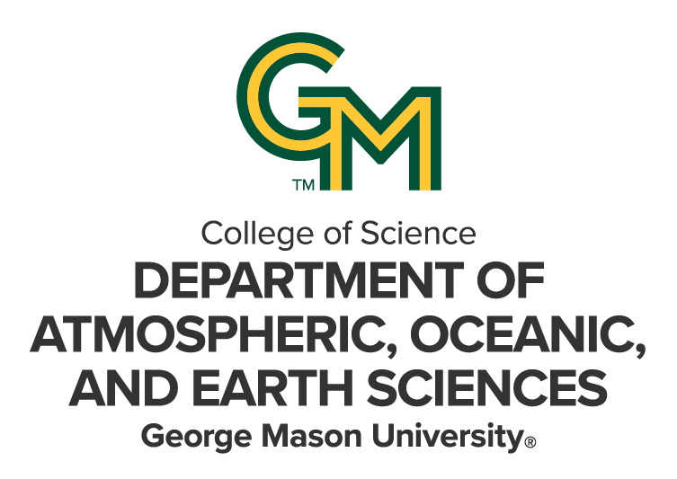

**Advisor Approval Department Form**

**Department of Atmospheric, Oceanic, and Earth Sciences**

**Applicant**: Please complete the top portion of the form and forward it to your potential faculty advisor.

For a list of potential advisors please [click here.](https://science.gmu.edu/academics/departments-units/atmospheric-oceanic-earth-sciences/faculty-and-staff) Contact them and explain your interests in our program, which degree you want to work on, and what your research or project focus might be and whether you require funding to support your study. Faculty may not be available sometimes but may be able to direct you to other potential advisors and might be able to serve on your committee.

**Faculty**: Please complete the remainder of the form and return it to the applicant.

Applicant’s Name __________________________________________ Program of Study _______________________

Advisor’s Name _____________________________________________ Email _____________________________________

Yes, I will advise this student.

No, I will not advise this student.

Comments from Faculty Advisor:

**Faculty Advisor Signature ________________________________________ Date ______________________**

If you have questions regarding this form, please contact [geolgrad@gmu.edu](mailto:geolgrad@gmu.edu).