GGS 412 – Air Photography Interpretation – 80565 - 003

Syllabus

Instructor: Dr. Ron Resmini

Course description and objective: GGS 412, Air Photography Interpretation, will provide students with the concepts, principles, methods, and techniques of interpreting and using information contained in photographic and nonphotographic aerial imagery including applications to various aspects of physical and cultural landscape (e.g., agriculture and forestry, urban and industrial features, geology and landforms). This course examines the use of various types of electromagnetic energy to obtain spatial and compositional information from remotely sensed imagery of the earth. Course content will also emphasize: 1) photographic and nonphotographic airborne and spaceborne remote sensing concepts, systems, and sensors; and 2) strategies for visual extraction of features from remote sensing imagery. The objective of this course is to provide students with in-depth knowledge of the concepts, theories, principles, technologies, and methods of interpreting remotely sensed imagery of the earth. Topics covered include:

- Introductory Concepts
Energy Sources
Energy Interactions
Remotely Sensed Data/Imagery
Remote Sensing Systems
- Photographic and Photogrammetric Principles
Film-Based Imaging; Cameras
Filters
Electronic Imaging
Geometric Characteristics of Photographs
- Image Analysis and Interpretation
Fundamentals
Various Applications
- Digital Image Processing: Summary & New Concepts
Image Enhancement
Image Manipulation
Information extraction; Applications
- Multispectral Remote Sensing/Thermal Imaging
Physical principles
Algorithms
Information extraction; Applications
- Hyperspectral Remote Sensing
Physical principles
Algorithms
Information extraction; Applications

- Remote Sensing Systems/Hardware; Airborne and Satellite
AVIRIS
Landsat
SPOT
Other Earth Resource Sensors
- Microwave and Lidar Sensing
Physical principles
Systems and sensors
Information extraction; Applications

Additional Information

- Textbook:
Remote Sensing and Image Interpretation, 7th Edition, 2015,
by Lillesand, Kiefer, and Chipman, John Wiley & Sons, publ.

- Class meeting:
Monday, 4:30 p.m. to 7:10 p.m., in Exploratory Hall 2312
- Office hours:
Monday, 3:30 p.m. to 4:30 p.m. or by appointment; Exploratory Hall 2212
- Software:
ENVI® v5.3 (or v5.x) (I suggest you purchase a student license but you have access to this software in Exploratory Hall 2312. I'll say more about this at the first class meeting.)

- Contact information:
Dr. Ron Resmini: rresmini@gmu.edu; v: 703-470-3022; Exploratory Hall 2212

- Assignments:
Weekly

- Exams:
One midterm exam (date: 16 Oct., 2017); in class, open book, open notes, etc.
One comprehensive final exam (date: 18 Dec., 2017); in class, open book, open notes, etc.

- Grading:
25% assignments, homework
30% midterm exam
25% final exam
20% mini-project

- Grading Policy:
Grading in GGS 412 will follow university policy.

From the online GMU University Catalog:
http://catalog.gmu.edu/policies/academic/grading/#text

Scroll down to: ‘AP.3.1 Undergraduate Grading’ and see the following:

"University coursework is measured in terms of quantity and quality. A credit normally represents one hour per week of lecture or recitation or not fewer than two hours per week of laboratory work throughout a semester. The number of credit hours is a measure of quantity, while the grade is a measure of quality. Faculty of record must assign a grade to all enrolled students at the end of the semester, term or part of term."

Letter Grade | Quality Points | Status
A+ | 4.00 | Passing
A | 4.00 | Passing
A- | 3.67 | Passing
B+ | 3.33 | Passing
B | 3.00 | Passing
B- | 2.67 | Passing
C+ | 2.33 | Passing
C | 2.00 | Passing
C- | 1.67 | Passing
D | 1.00 | Passing
F | 0.00 | Failing

For this course, letter grades are based on the following numerical score ranges:

Letter Grade | Percentage Points
A+ | 100.0 – 97.0
A | 96.9 – 93.0
A- | 92.9 – 90.0
B+ | 89.9 – 87.0
B | 86.9 – 83.0
B- | 82.9 – 80.0
C+ | 79.9 – 77.0
C | 76.9 – 73.0
C- | 72.9 – 70.0
D | 69.9 – 60.0
F | ≤ 59.9

- Important websites:

USGS EarthExplorer: http://earthexplorer.usgs.gov/
NASA Earth Observatory: http://www.earthobservatory.nasa.gov/
NASA Earth Science Enterprise: http://www.earth.nasa.gov/
NASA GSFC Landsat programs: http://landsat.gsfc.nasa.gov/
USGS Landsat Program: http://landsat7.usgs.gov/
EROS Data Center: https://eros.usgs.gov/usa
ASPRS homepage: http://www.asprs.org/

- Important journals (there are many others, too):

Remote Sensing of Environment (RSE)
ASPRS Photogrammetric Engineering & Remote Sensing (PE&RS)
IEEE Transactions on Geosciences and Remote Sensing (IEEE TGARS)
International Journal of Remote Sensing (IJRS)

- Other textbooks that are great remote sensing references (but not required):

Adams, J.B., and Gillespie, A.R., (2006). Remote Sensing of Landscapes with Spectral Images: A Physical Modeling Approach. Cambridge University Press, 362 p.

Campbell, J.B., (2007). Introduction to Remote Sensing, 4th edition. The Guilford Press, New York, NY, 626 p.

Jensen, J.R., (2007). Remote Sensing of the Environment: An Earth Resource Perspective. 2nd edition. Prentice Hall Series in Geographic Information Science, Upper Saddle River, NJ, 608 p.

Jensen, J.R., (2005). Introductory Digital Image Processing. 3rd edition. Prentice Hall Series in Geographic Information Science, Upper Saddle River, NJ, 544 p.

Landgrebe, D.A., (2003). Signal Theory Methods in Multispectral Remote Sensing. Wiley-Interscience, John Wiley and Sons, New Jersey, 508 p.

Richards, J.A., and Jia, X., (1999). Remote Sensing Digital Image Analysis, An Introduction, 3rd, Revised and Enlarged Edition. Springer, Berlin, 363 p.

Sabins, F.F., (2007). Remote Sensing: Principles and Interpretation, 3rd Edition. Waveland Pr. Inc., 512 p.

Schott, J.R., (1997). Remote Sensing: The Image Chain Approach. Oxford University Press, New York, 394 p.

Schedule and textbook reading assignments (tentative; the schedule may change):

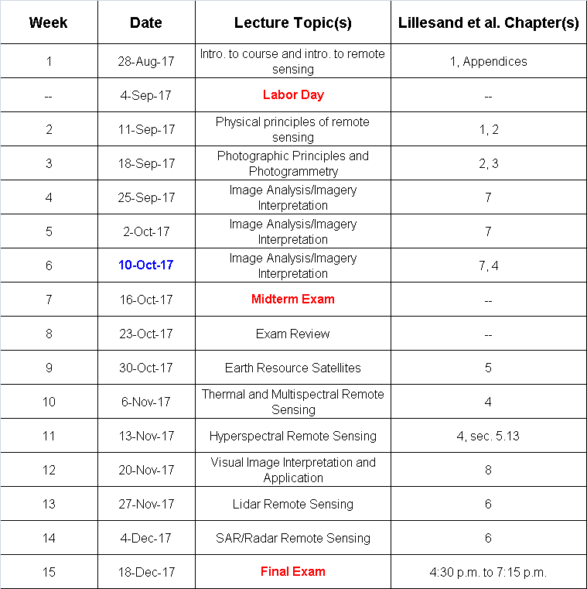

See also: http://registrar.gmu.edu/calendars/fall-2017/

Academic Integrity/Honor Code: Students are expected to review and abide by the GMU Honor Code (http://oai.gmu.edu/the-mason-honor-code/).

