GGS 579 - Remote Sensing – 10951 - 001

Syllabus

Instructor: Dr. Ron Resmini

Course description and objective: GGS 579, Remote Sensing, will provide graduate students with the concepts, principles, and methods of earth remote sensing. This course examines the use of various types and combinations of electromagnetic energy to obtain spatial and compositional information. Course content concentrates on: 1) nonphotographic, airborne, and spaceborne remote sensing concepts, systems, and sensors; and 2) essential operational parameters for existing and future systems and strategies for visual and digital extraction of features and information. The objective of this course is to provide graduate students with in-depth knowledge of the concepts, theories, principles, technologies, and methods of earth remote sensing and remote sensing data analysis.

Credit hours: 3

- Introductory Concepts
Energy Sources
Energy Interactions
Data
Remote Sensing Systems
- Photographic and Photogrammetric Principles (brief overview)
Film-Based Imaging, cameras
Filters
Electronic Imaging
Geometric Characteristics of Photographs
- Image Analysis and Interpretation
Fundamentals
Various Applications
- Digital Image Processing: Summary & New Concepts
Image Enhancement
Image Manipulation
Information extraction
- Multispectral Remote Sensing/Thermal Imaging
Physical principles
Algorithms
Applications
- Hyperspectral Remote Sensing
Physical principles
Algorithms
Applications

- Remote Sensing Systems/Hardware; Airborne and Satellite
AVIRIS
Landsat
SPOT
Other Earth Resource Sensors
- Microwave and Lidar Sensing
Physical principles
Systems and sensors
Data and applications

Additional Information

- Textbook:
Remote Sensing and Image Interpretation, 7th Edition, 2015,
by Lillesand, Kiefer, and Chipman, John Wiley & Sons, publ.

- Class meeting:
Wednesday, 4:30 p.m. to 7:10 p.m. in Exploratory Hall 2310
- Office hours:
Wednesday, 3:30 p.m. to 4:30 p.m. or by appointment, Exploratory Hall 2212
- Contact information:
Dr. Ron Resmini: rresmini@gmu.edu; v: 703-470-3022 (voice and text)

- Assignments:
1) Weekly
2) A mini-project (a PowerPoint briefing)

- Software:
ENVI® v5.5 (or v5.x) (I suggest you purchase a student license but you have access to this software in Exploratory Hall 2310. I'll say more about this at the first class meeting.)

- Exams:
One midterm exam (date: 20 Mar., 2019); in class, open notes, open book
One final exam (date: 8 May, 2019); in class, open notes, open book; cumulative

- Grading:
25% assignments, homework
20% term mini-project
30% midterm exam
25% final exam

- Grading Policy:
Grading in GGS 579 will follow university policy.

From the online GMU University Catalog:
http://catalog.gmu.edu/policies/academic/grading/#text

Scroll down to: ‘AP.3.2 Graduate Grading’ and see the following:

Grade Quality Points Graduate Courses
A+ 4.00 Satisfactory/Passing
A 4.00 Satisfactory/Passing
A- 3.67 Satisfactory/Passing
B+ 3.33 Satisfactory/Passing
B 3.00 Satisfactory/Passing
B- 2.67 Satisfactory/Passing
C 2.00 Unsatisfactory/Passing
F 0.00 Unsatisfactory/Failing

* Although a B- is a satisfactory grade for a course, students must maintain a 3.00 average in their degree program and present a 3.00 GPA on the courses listed on the graduation application.”

For this class, letter grades are based on the following numerical score ranges:

A+ ≥ 97.0 to 100.0
A ≥ 93.0 to < 97.0
A- ≥ 90.1 to < 93.0
B+ ≥ 83.3 to < 89.9
B ≥ 76.7 to < 83.3
B- ≥ 70.1 to < 76.7
C ≥ 60 to < 70.1
F <= 59.9

- Important websites:

USGS EarthExplorer: http://earthexplorer.usgs.gov/
NASA Earth Observatory: http://www.earthobservatory.nasa.gov/
NASA Earth Science Enterprise: http://www.earth.nasa.gov/
NASA GSFC Landsat programs: http://landsat.gsfc.nasa.gov/
USGS Landsat Program: http://landsat7.usgs.gov/
EROS Data Center: https://eros.usgs.gov/usa
ASPRS homepage: http://www.asprs.org/
There are many others!

- Important journals (there are many others, too):

Remote Sensing of Environment (RSE)
ASPRS Photogrammetric Engineering & Remote Sensing (PE&RS)
IEEE Transactions on Geosciences and Remote Sensing (IEEE TGARS)
International Journal of Remote Sensing (IJRS)

- Other textbooks that are great remote sensing references (but not required):

Adams, J.B., and Gillespie, A.R., (2006). Remote Sensing of Landscapes with Spectral Images: A Physical Modeling Approach. Cambridge University Press, 362 p.

Campbell, J.B., (2007). Introduction to Remote Sensing, 4th edition. The Guilford Press, New York, NY, 626 p.

Hapke, B., (1993). Theory of Reflectance and Emittance Spectroscopy. Cambridge University Press, 455 p.

Hecht, E., (1987). Optics, 2nd Edition. Addison-Wesley Publishing Company, Reading, Massachusetts, 676 p.

Jensen, J.R., (2007). Remote Sensing of the Environment: An Earth Resource Perspective. 2nd edition. Prentice Hall Series in Geographic Information Science, Upper Saddle River, NJ, 608 p.

Jensen, J.R., (2005). Introductory Digital Image Processing. 3rd edition. Prentice Hall Series in Geographic Information Science, Upper Saddle River, NJ, 544 p.

Landgrebe, D.A., (2003). Signal Theory Methods in Multispectral Remote Sensing. Wiley-Interscience, John Wiley and Sons, New Jersey, 508 p.

Richards, J.A., (2013). Remote Sensing Digital Image Analysis, An Introduction, 5th Edition. Springer, Berlin, 494 p.

Sabins, F.F., (2007). Remote Sensing: Principles and Interpretation, 3rd Edition. Waveland Pr. Inc., 512 p.

Schott, J.R., (2007). Remote Sensing: The Image Chain Approach. 2nd Ed., Oxford University Press, New York, 688 p.

Solé, J.G., Bausá, L.E., and Jaque, D., (2005). An Introduction to the Optical Spectroscopy of Inorganic Solids. John Wiley & Sons, Ltd., 283 p.

- Schedule and textbook reading assignments (the schedule may change):

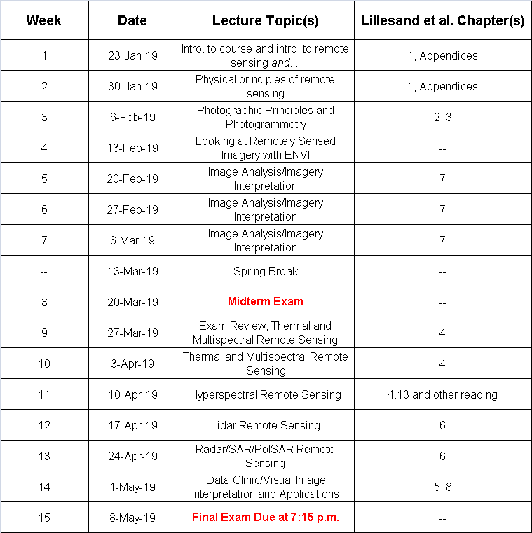

See also: https://registrar.gmu.edu/calendars/spring-2019/

Academic Integrity/Honor Code: Students are expected to review and abide by the GMU Honor Code (http://oai.gmu.edu/the-mason-honor-code/).

