George Mason University
Department of Geography and Geoinformation Sciences
GGS 101: Major World Regions – Fall 2022

Class time: Mondays and Wednesdays from 12:00 pm – 1:15 pm

Location: Planetary Hall, Room 131

Instructor: Lori Mandable (she/her)
Exploratory Hall, Room 2204
lmandabl@gmu.edu
Office: 703-993-3923
Mobile: 703-966-5316

GTA: TBD
TBD

Learning Amanda Webber (she/her)
Assistant: Exploratory Hall, Room 2400 C/D
awebber5@gmu.edu
Discord: https://discord.gg/TcrWBvczrK

Office hours: Lori: Monday – Tuesdays and Thursdays 1pm-3pm and by appointment in 2204 Exploratory Hall, and via Zoom Personal Meeting Room at https://gmu.zoom.us/j/2749469680

GTA: TBD

Amanda: Tuesdays 10am-12pm and by appointment on other days as needed

Overview: GGS 101 provides a survey of cultural, physical, and societal aspects of major world regions. We will examine how forces across various scales, from local to global, shape the character of place and space. Furthermore, we will explore how regions differ from one another, are similar to one another, and interact with/interrelate to one another in today’s globalizing world. Acquiring a familiarity with and a foundation in the geography of the major world regions allows us to ask more critical questions about the unevenness of various geographical processes and patterns on the landscape in addition to reflecting on our own role in the larger world..

Mason Core: Global Understanding
The goal of the global understanding category is to help students see the world from multiple perspectives, reflect upon their positions in a global society, and be prepared for future engagement as global citizens. While it may include a historical perspective, global understanding courses focus primarily on a contemporary understanding of one’s place in a global society.

Learning Outcomes:

Courses in this category must meet a minimum of three of the following learning outcomes:
1. Identify and articulate one’s own values and how those values influence their interactions and relationships with others, both locally and globally.
2. Demonstrate understanding of how the patterns and processes of globalization make visible the interconnections and differences among and within contemporary global societies.
3. Demonstrate the development of intercultural competencies.
4. Explore individual and collective responsibilities within a global society through analytical, practical, or creative responses to problems or issues, using resources appropriate to the field.

The following rubric will be used to help assess learning in the class, particularly with written assignments:
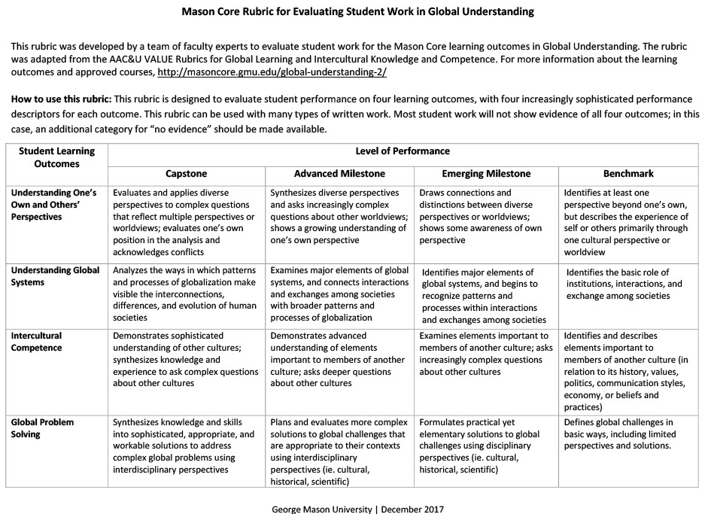
Required Textbook: Finlayson, Caitlin. World Regional Geography
Note: this is a free, online educational textbook!
https://worldgeo.pressbooks.com/

Grading: Grades for this course are based on individual performance in the following areas:
Assignment | Frequency or Date | Possible Points | Percent of Total | Where
10 Post-Reading Quizzes | Due after each chapter covered | 10 points each for a total of 100 points | 10% | Blackboard
10 Map Exercises | Roughly every other week | 20 points each for a total of 200 points | 20% | Blackboard
2 Assignments | 10/17/2022  11/14/2022 | 100 points each for a total of 200 points | 20% | Blackboard
Class Participation | Various | 100 possible points | 10% | In Class
Exam 1 | 9/21/2022 | 100 points | 10% | In Class
Exam 2 | 10/19/2022 | 100 points | 10% | In Class
Exam 3/Final | 12/12/2022 | 150 points | 15% | In Class
Total |  | 1000 points | 100%

Grading Schema
Grade | Percentage | Points
A+ | 97-100% | 970-1000
A | 94-96.99% | 940-969.9
A- | 90-93.99% | 900-939.9
B+ | 87-89.99% | 870-899.9
B | 84-86.99% | 840-869.9
B- | 80-83.99% | 800-839.9
C+ | 77-79.99% | 770-799.9
C | 74-76.99% | 740-769.9
C- | 70-73.99% | 700-739.9
D | 60-69.99% | 600-699
F | <60% | <600
Quizzes: Quizzes on each chapter (Chapters 1-10) will be given via Blackboard. These quizzes are open book, open note, but no collaboration from other people and no use of the internet for answers. They may be taken twice for credit and the highest grade will be used.

Assignments: There will be 2 graded assignments throughout the semester based on an area of your choice and thought provoking questions based on material from the text.

Class Participation – we will have several discussions, in-class/hands-on assignments during the semester to encourage attendance. These discussions/assignments comprise 100 points of the total grade for this class and CANNOT be made up if a student has an unexcused absence.

Exams: There will be 3 in class exams, taken on the date(s) specified on the syllabus. The first exam will cover the Introduction chapter and Chapters 1-3. The second exam will cover Chapters 4-6 of the text and the final exam will be comprehensive, but will focus more on the material from Chapters 7-10.

Instructor Policies

- Attendance is key to doing well in this course. Several scientific studies conclusively correlate academic success with regular class attendance. While the instructor does not take attendance for class, it is expected that all students will attend class as much as possible. If you must miss a class, please let the instructor know ahead of time via email or text message. It is the student’s responsibility to meet with the instructor to follow up on any missed material.
- Absences: Make up exams, make up unannounced quizzes/participation assignments, late submissions of labs, and other graded material will only be accepted at the discretion of the instructor for DOCUMENTED extenuating circumstances. Missed quizzes, exams and late submissions of labs and other graded work will receive a grade of 0 and it is the student’s responsibility to follow up with the instructor regarding a documented extenuating circumstance.
- Respect for Others: Discussions on topics such as inequality of resources will occur in this class. Please be kind and respectful to fellow students, Learning Assistant(s) and the Professor. Remember your audience and use proper professional etiquette and language. We all bring our wonderful and unique experiences and perspectives to class. A foundation of respect and acknowledgement of diverse perspectives enables everyone to benefit from our collected insights.
- Use of electronic devices/cell phones: Please do not engage in activities that are unrelated to the class on the class computers and any private electronic devices brought into the classroom. Please mute cell phones prior to class commencing. If you do need to receive an incoming call during the class period, please step outside the classroom to take the call.
- Email policy: The instructor will return emails and text messages as quickly as possible Monday through Friday. If you send an email on Saturday or Sunday it could be a full 24-48 hours before the instructor is able to respond.

University Policies
- Catalog: The University Catalog (http://catalog.gmu.edu) is the central resource for university policies affecting student, faculty, and staff conduct in university academic affairs. Other policies are available at http://universitypolicy.gmu.edu/. All members of the university community are responsible for knowing and following established policies.
- Email: Students must use their MasonLive email account to receive important University information, including communications related to this class. The instructor will not respond to messages sent from or send messages to a non-Mason email address. See http://masonlive.gmu.edu for more information.
- Inclement Weather and Class Cancelation: GMU posts closings on its website (www.gmu.edu.) You can receive notification from Mason Alerts via email or text to a cell phone; please let the instructor know if you need more information.
- Registration: Instructors do not have the capacity to remove students from class enrollment, therefore students are responsible for any changes in enrollment.
- Honor Code: Students of this course must be familiar with the GMU honor code, which can be viewed via this link: http://www.gmu.edu/catalog/9798/honorcod.html#code.
Three fundamental and rather simple principles to follow at all times are that: (1) all work submitted be your own; (2) when using the work or ideas of others, including fellow students, give full credit through accurate citations; and (3) if you are uncertain about the ground rules on a particular assignment, ask the instructor for clarification. No grade is important enough to justify academic misconduct. Plagiarism means using the exact words, opinions, or factual information from another person without giving the person credit. Writers give credit through accepted documentation styles, such as parenthetical citation, footnotes, or endnotes. Paraphrased material must also be cited, using MLA or APA format. A simple listing of books or articles is not sufficient. Plagiarism is the equivalent of intellectual robbery and cannot be tolerated in the academic setting. If you have any doubts about what constitutes plagiarism, please see the instructor.
Any violation of the honor code is taken seriously and will be reported.
Pursuant to OAI policy, for any cases of cheating faculty must give two recommendations for sanctions, for first and second offenses. My recommendations will be as follows:
1st Offense: ‘F’ for the course and academic probation
2nd Offense: Expulsion from the university
- George Mason Diversity Statement:
George Mason University promotes a living and learning environment for outstanding growth and productivity among its students, faculty and staff. Through its curriculum, programs, policies, procedures, services and resources, Mason strives to maintain a quality environment for work, study and personal growth.
An emphasis upon diversity and inclusion throughout the campus community is essential to achieve these goals. Diversity is broadly defined to include such characteristics as, but not limited to, race, ethnicity, gender, religion, age, disability, and sexual orientation. Diversity also entails different viewpoints, philosophies, and perspectives. Attention to these aspects of diversity will help promote a culture of inclusion and belonging, and an environment where diverse opinions, backgrounds and practices have the opportunity to be voiced, heard and respected.
The reflection of Mason’s commitment to diversity and inclusion goes beyond policies and procedures to focus on behavior at the individual, group and organizational level. The implementation of this commitment to diversity and inclusion is found in all settings, including individual work units and groups, student organizations and groups, and classroom settings; it is also found with the delivery of services and activities, including, but not limited to, curriculum, teaching, events, advising, research, service, and community outreach.
Acknowledging that the attainment of diversity and inclusion are dynamic and continuous processes, and that the larger societal setting has an evolving socio-cultural understanding of diversity and inclusion, Mason seeks to continuously improve its environment. To this end, the University promotes continuous monitoring and self-assessment regarding diversity. The aim is to incorporate diversity and inclusion within the philosophies and actions of the individual, group and organization, and to make improvements as needed.
- Support Resources:
Office of Disability Services: If you have a documented learning disability or other condition that you believe will impact your academic performance: 1) Consult with the Office of Disability Services (SUB I, Rm. 2500; 703-993-2474; http://ods.gmu.edu) so that they can document the issues and determine about proper accommodations and 2) Provide the professor with the documentation of accommodations provided by ODS. As a matter of university policy, faculty cannot provide accommodations without documentation from the ODS.
Responsible Employee: As a faculty member and designated “Responsible Employee,” the instructor is required to report all disclosures of sexual assault, interpersonal violence, and stalking to Mason’s Title IX Coordinator per university policy 1412.
Confidential Support Services: If you wish to speak with someone confidentially, please contact the Student Support and Advocacy Center (703-380-1434) or Counseling and Psychological Services (703-993-2380). You may also seek assistance from Mason’s Title IX Coordinator (703-993-8730; titleix@gmu.edu).
Additional Support Services: Several departments exist to aid students in a wide variety of ways and are listed on the last pages of this syllabus.

GGS 101 Calendar – Fall 2022

***Syllabus is subject to change, so check Blackboard for the most up to date version!
Week | Date | Chapter(s) Covered | Due Dates **
1 | 8/22 | Syllabus and Course Information
 | 8/24 | Chapter 1: Introduction
2 | 8/29 | Chapter 1: Introduction | Latitude/Longitude Map Exercise Due
 | 8/31 |  | Global Map Due
3 | 9/5 | NO CLASS TODAY – Labor Day Holiday
 | 9/7 | Chapter 2: Europe | Chapter 1 Quiz Due
4 | 9/12 | Chapter 2: Europe
 | 9/14 | Chapter 3: Russia | Map of Europe Due
5 | 9/19 | Chapter 3: Russia | Chapter 2 Quiz Due
 | 9/21 | Exam 1
6 | 9/26 | Chapter 4: North America | Chapter 3 Quiz Due
 | 9/28 |  | Map of North & Central America Due
7 | 10/3 | Chapter 5: Middle and South America | Chapter 4 Quiz Due
 | 10/5
8 | Tues 10/11 | Chapter 5: Middle and South America | Maps of South America and Caribbean Due
 | 10/12 | Chapter 6: Sub-Saharan Africa | Chapter 5 Quiz Due
9 | 10/17 | Chapter 6: Sub-Saharan Africa | Assignment 1 Due
 | 10/19 | Exam 2
10 | 10/24 | Chapter 7: North Africa & Southwest Asia | Chapter 6 Quiz Due
 | 10/26 |  | Map of Africa Due
11 | 10/31 | Chapter 8: South Asia | Chapter 7 Quiz Due
 | 11/2
12 | 11/7 | Chapter 8: South Asia
 | 11/9 | Chapter 9: East & Southeast Asia | Chapter 8 Quiz Due
13 | 11/14 | Chapter 9: East & Southeast | Assignment 2 Due
 | 11/16 |  | Maps of Asia and Middle East Due
14 | 11/21 | NO CLASS THIS WEEK – THANKSGIVING BREAK
 | 11/23
15 | 11/28 | Chapter 10: Oceania | Chapter 9 Quiz Due
 | 11/30 |  | Map of Oceania/Australia Due  Chapter 10 Quiz Due
Final Exam | Monday, December 12th from 10:30am – 1:15pm |  | Exam 3/Final Exam is COMPREHENSIVE (Chapters 1-10), but the majority of the exam will cover Chp 7-10.

** Items that are due must be submitted by 11:59pm Eastern Time on the dates indicated above for grading consideration.
Student Support Services:
NAME OF RESOURCE | DESCRIPTION OF RESOURCE
Academic Advising | www.advising.gmu.edu
Assistive Technology Initiative | Aquia Building Rm. 238 703-993-4329 www.ati.gmu.edu  Manages the production of accessible text for Mason students with disabilities. They also ensure access to information technology and communications to the entire university community through the use of adaptive equipment and provision of technical assistance.
Center for Culture, Equity, and Empowerment (formerly ODIME and LBGTQ+) | SUB I Room 2400 703-993-2700 www.ccee.gmu.edu  Leverages programs and services focused on advocacy and direct student support to strengthen equity and inclusion at George Mason University. Our advising fosters opportunities for identity development, cross-cultural engagement, and inclusive learning communities, affirming the indivisible aspects of all our identities. Our three areas: Student Access and Equity (SAE), Student Engagement for Racial Justice (SERJ), and LGBTQ+ Resources, serve as resources to those in the Mason Community who seek to meaningfully engage and interact with people with different identities and intersections to co-create an equitable campus environment.
Counseling and Psychological Services | SUB I Room 3129 703-993-2380 www.caps.gmu.edu  Students can take advantage of psychological services, a variety of learning services, multicultural services, and educational programs that support students’ educational goals.
Disability Services | SUB I Room 2500 703-993-2474 www.ds.gmu.edu  Implements and coordinates reasonable accommodations and disability-related services that afford equal access to university programs and activities.
International Programs and Services | SUB I Room 4300 703-993-2970 www.oips.gmu.edu  Provides guidance to students and scholars studying and working at George Mason University on immigration, employment and taxation, and adjustment issues, while fostering cross-cultural understanding through programs highlighting global themes.
Learning Services | SUB I Room 3129 703-993-2380 www.learningservices.gmu.edu Provides a variety of experience based learning opportunities through which students explore a wide range of academic concerns. Services include support to students with learning differences, individual study skills counseling, individualized programs of study, and provision of tutoring resources. Presentations on a variety of academic skill topics are available to the university community. The programs are open to all George Mason University students free of charge. Services are confidential and use of these services does not become part of the student’s academic record.
Mason Student Services Center | SUB I Room 1003 www.mssc.gmu.edu  Provides one-stop, integrated information and referrals regarding admissions, registrar, student accounts, and financial aid.
Mathematics Tutoring Center | Exploratory Hall 703-993-3622  www.science.gmu.edu/academics/departments-units/mathematical-sciences/math-tutoring  Offers tutoring on a walk-in basis for all George Mason University students who are enrolled in math courses up to MATH 290.
Office of Academic Integrity | SUB I Room 4100 703-993-6209 www.oai.gmu.edu  Provides information on the honor code and resources for students and faculty.
Office of Coalition Building and Diversity Education (CBDE) | SUB I Room 2400 703-993-2700 www.cbde.gmu.edu  Through collective and collaborative work with campus and community partners, supports, builds, and enhances the understanding of interpersonal identities to respond to systemic inequities, through engagement, advocacy, and education. CBDE aims to be a catalyst for change by creating, promoting and sustaining an inclusive and equitable campus community.
Office of Compliance, Diversity and Ethics | Aquia Building Room 373 703-993-8730 www.cde.gmu.edu  The Office of Compliance, Diversity and Ethics provides leadership and support on matters relating to equity, diversity, access, respect and inclusiveness for all members of the George Mason University community.
Office of Military Service | SUB I 703-993-1316 www.military.gmu.edu  Assists U.S. Military veterans, their dependents and survivors with navigating the complex benefits process. Also provides career assistance and social opportunites for military and veteran students.
Safe Zone | SUB I Room 2200 703-993-2702 www.lgbtq.gmu.edu/safe-zone/ Creates a safer, more welcoming and inclusive campus environment to strengthen community and encourage networking among faculty, staff, and students toward the goal of supporting the well-being of LGBTQ people.
Social Action and Integrative Learning (SAIL) | Enterprise Hall Room 442 703-993-2900 www.sail.gmu.edu  Fosters experiential learning opportunities on campus, regionally, and globally for the Mason community with a particular emphasis on effecting positive social change. SAIL is Mason’s home for service-learning initiatives.
Student Conduct | SUB I Room 4100 703-993-6209 www.studentconduct.gmu.edu Provides information about university policies, the student conduct process, and resources for faculty related to addressing student behaviors of concerns and other disruptive behaviors.
Student Health Services | SUB I Room 2300 703-993-2831 www.shs.gmu.edu  Provides high quality health care, counseling, education, and prevention services in support of student learning and retention.
Student Support and Advocacy Center | SUB I Room 3200 703-993-3686 www.ssac.gmu.edu  Provides comprehensive services for students in an effort to foster the safety and well-being of the Mason community. SSAC services include assisting students who are encountering barriers to their academic success or personal growth, interpersonal violence prevention, alcohol and drug education, health promotion/healthy relationships, student crisis intervention, and connecting students with appropriate campus and off-campus resources.
University Career Services | SUB I Room 3400 703-993-2370 www.careers.gmu.edu  Provides information on career choices, internships and employment, and graduate and professional school.
UNIV Courses and Programs | www.transitions.gmu.edu  Serves as a resource and development center for undergraduates, providing courses, programs, and services to facilitate students’ personal and academic success.
University Life | Merten Hall Room 5200 703-993-8760 www.ulife.gmu.edu  Enhances students’ in- and out-of-class experiences, in addition to facilitating interactions among faculty, staff, and other students. These resources help students achieve academically, stay healthy, get involved with campus life, find jobs, and identify resources to enrich their learning.
University Writing Center | Johnson Ctr Room 227E 703-993-1200 www.writingcenter.gmu.edu  Offers free individual writing consultations for students, who choose between meeting a tutor on Zoom or submitting a draft for the tutor’s written feedback. Also offers online writing guides on specific genres of writing, citation style, and other topics. Additionally, the Writing Center provides assistance to faculty who are interested in holding in-class writing workshops, developing effective writing assignments, or evaluating students’ writing.

