George Mason University

Department of Geography and Geoinformation Sciences
GGS 102-001: Introduction to Physical Geography – Spring 2023

Class time: Mondays and Wednesdays from 10:30 am – 11:45 am

Location: Horizon Hall, Room 1014

Instructor: Lori Mandable (she/her)
Exploratory Hall, Room 2204
lmandabl@gmu.edu
Zoom Personal Meeting Room
Office: 703-993-3923
Mobile: 703-966-5316

Learning Shannon Ellis (she/her)
Assistant: Exploratory Hall, Room 2400 C/D
sellis21@gmu.edu
Discord: https://discord.gg/RkJjahU7

Graduate Mengfei Xin (she/her)
Teaching Exploratory Hall, Room
Assistant: mxin2@gmu.edu

Office hours: Lori: Monday-Thursday 2:45pm-3:45pm in 2204 Exploratory Hall and via Zoom
(I’m happy to schedule an appointment if these times don’t work for you – just ask!)
Shannon: Wednesdays and Thursdays from 3:30pm-5:30pm and by appointment

Mengfei: Tuesdays from 2pm-5pm via Blackboard Collaborate Ultra. Go to the course on Blackboard, then click the Blackboard Collaborate Ultra link on the left side. The course room will be at the top of the page and click it to get into the room.

Course Description
Have you ever wondered about the remarkable planet on which we live? Have you seen a picture of a landscape and wanted to know more about where it is from and how it became so stunning? In this course, we discover Earth’s major landforms, how they were created, and the processes that continually change the landscape of our planet. We will learn how these factors are interrelated processes, that direct the global distribution and character of climate, soils, vegetation, hydrology, and landforms. We will examine how these interrelated processes also impact our daily lives, and how humans influence the environment through the application of the scientific method. The course also includes basic elements of mapping and is designated as a Mason Core (non-laboratory) Natural Sciences course as well as a Green Leaf Sustainability-Related course.

Course Goals
Welcome to GGS 102! The goals of this course are to help engage your curiosity about Earth, learn how the scientific method advances our knowledge of Earth, and apply that knowledge to constructively solve problems. It’s designed to be an experience where you will learn not only about Earth and its processes, but also where you can develop the skills necessary to help you academically. By the end of this course, you will be able to:
- Explain the six steps of the scientific method through application to an area and topic of their choice
- Describe the difference in perspective, tone and data presented in media-based articles vs. peer-reviewed literature
- Demonstrate geographic analysis techniques through pattern recognition in Earth’s atmosphere, biosphere, lithosphere, hydrosphere, and human settlement
- Identify landform types and describe the processes that formed them.

Mason Core: Natural Science
Mason Core Natural Science courses engage students in scientific exploration; foster their curiosity; enhance their enthusiasm for science; and enable them to apply scientific knowledge and reasoning to personal, professional, and public decision-making. This course meets learning outcomes 1 through 4 for Natural Science.

Learning Outcomes:
- Understand how scientific inquiry is based on investigation of evidence from the natural world, and that scientific knowledge and understanding: a) evolves based on new evidence, and b) differs from personal and cultural beliefs.
- Recognize the scope and limits of science.
- Recognize and articulate the relationship between the natural sciences and society and the application of science to societal challenges (e.g., health, conservation, sustainability, energy, natural disasters, etc.).
- Evaluate scientific information (e.g., distinguish primary and secondary sources, assess credibility and validity of information).

Green Leaf Sustainability-Related
Green Leaf Sustainability-Related courses “help build knowledge about a component of sustainability (people, planet, and profit) or introduce students to sustainability concepts during part of the course. They may complement sustainability-focused courses by providing students with in-depth knowledge of a particular aspect or dimension of sustainability (such as the natural environment) or by providing a focus area (such as renewable energy) for a student’s sustainability studies, or they may broaden students’ understanding of sustainability from within different disciplines.”
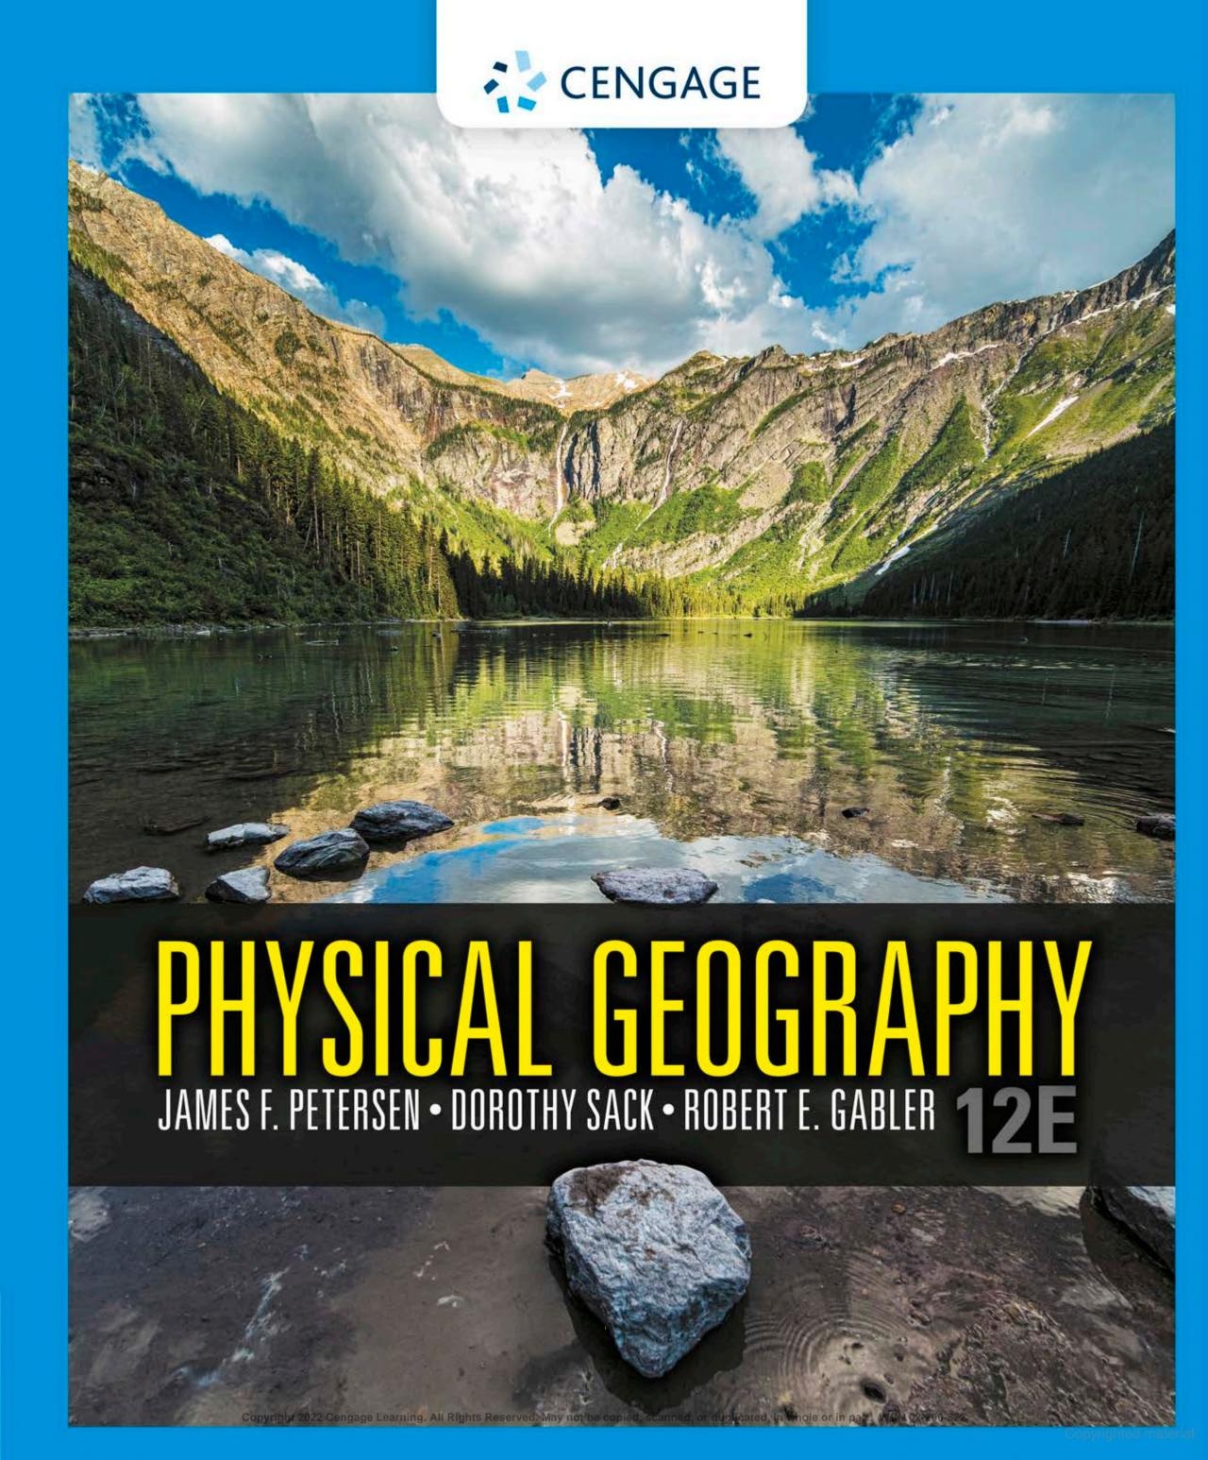

Required Materials
- Physical Geography (either print version or eText) 12th edition by Petersen, Sack and Gabler, ISBN: 978-0-357-14244-8. The text can be rented or purchased at the GMU Bookstore, 3rd party sites (Amazon, etc.) or via the publisher.
- Access to a computer with an operating system of at least Windows 10, Mac OSX 10.13 or higher and a stable broadband internet connection. Students have access to such computers in the GGS Computer Lab, 2102 Exploratory Hall, which is open to students 24/7 via their student ID.
- A photo (hard copy or digital) of a place that you have a connection to; it can contain people, but the emphasis is on the landscape
- Your curiosity and desire to learn!

Grading
Grades for this course are based on individual performance in the following areas:
Assignment | Frequency or Date | Possible Points | Percent of Total | Where
20 Post-Reading Quizzes | Due dates listed in Course Schedule section, lowest 2 quizzes dropped | 10 points each for total of 180 points | 18% | Blackboard
5 Assignments, 1 Optional Bonus Assignment | 2/1/2023,  2/27/2023,  3/29/2023,  4/17/2023  5/3/2023  Bonus: 5/3/2023 | 50 points each for a total of 300 points | 30% | Blackboard
14 Class Participations | Some listed on Course Schedule, lowest 2 grades dropped | 10 points each for a total of 120 points | 12% | In Class
Exam 1 | 2/22/2023 | 100 points | 10% | In Class
Exam 2 | 4/5/2023 | 100 points | 10% | In Class
Final Exam | 5/10/2023 | 200 points | 20% | In Class
Total |  | 1000 points | 100%

Grading Schema
Grade | Percentage | Points
A+ | 97-100% | 970-1000
A | 94-96.99% | 940-969.9
A- | 90-93.99% | 900-939.9
B+ | 87-89.99% | 870-899.9
B | 84-86.99% | 840-869.9
B- | 80-83.99% | 800-839.9
C+ | 77-79.99% | 770-799.9
C | 74-76.99% | 740-769.9
C- | 70-73.99% | 700-739.9
D | 60-69.99% | 600-699
F | <60% | <600

Quizzes: Quizzes on each chapter (Chapters 1-20) will be given via Blackboard. These quizzes are open book, open note, but no collaboration from other people and no use of the internet for answers. They may be taken twice for credit and the highest grade will be used. The lowest two quiz grades will be dropped.

Assignments: There will be 5 graded assignments throughout the semester based on your personal experience with an area of your choice and thought-provoking questions based on material from the text. Students are expected to answer each question in complete sentences – one-word answers will not be considered a complete sentence.
Questions asked in the assignments may require students to do some research. Research sources used should be peer-reviewed (unless specifically stated not to use a peer-reviewed source) and must be cited in APA format. This website provides information on APA basics: https://owl.purdue.edu/owl/research_and_citation/apa_style/apa_formatting_and_style_guide/in_text_citations_the_basics.html
Peer-reviewed sources are considered the “gold standard” in scientific research. To access a peer-reviewed source, go to the GMU library website: https://library.gmu.edu/. In the search box at the top of the page, type in the subject of interest (for the example below, I typed in Climate Change), then click on the magnifying glass icon next to the search criteria.

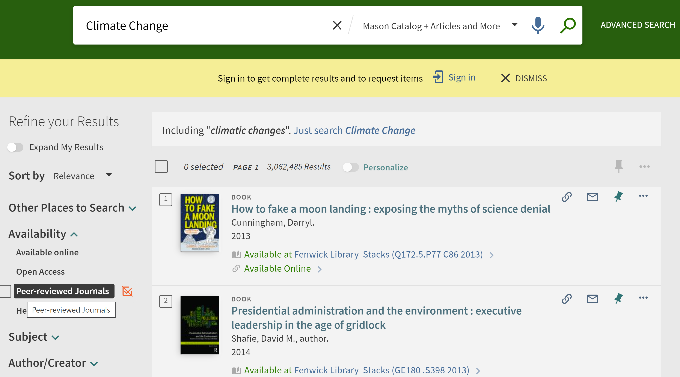
Where you see the red circle in the picture above, click on the box to put a checkmark in it, then click the Apply Filters button. The results then displayed will be peer-reviewed sources, which is also shown in the upper left side of the page under Active filters and below each result.

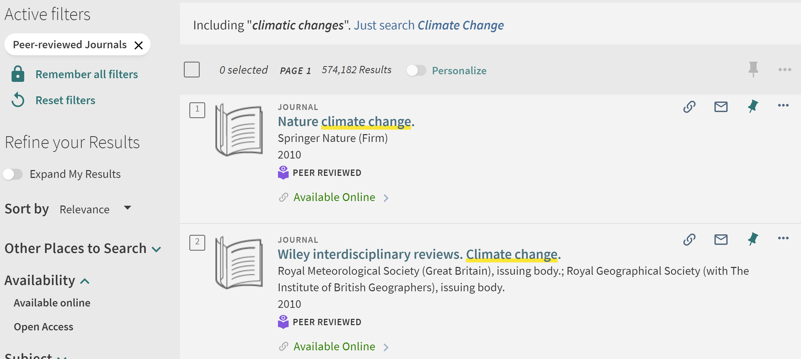

Class Participation - there will be 14 unannounced class participation assignments given in class during the semester to encourage attendance. These assignments comprise 120 points of the total grade for this class and CANNOT be made up. The lowest two class participation activity scores will be dropped.

Exams: There will be 3 in-class exams, taken on the date(s) specified on the syllabus. The first exam will cover Chapters 1-6. The second exam will cover Chapters 7-10 and 13-15 of the text. The final exam will be comprehensive (Chapters 1-20) but will have more emphasis on Chapters 16-20 and 11-12.

Extra Credit: There will be one and only one individual opportunity to earn bonus points this semester, through the completion of an optional Assignment 6 (worth 50 points).

Course Evaluations: There is one additional group opportunity to earn bonus points, through completion of the course evaluation at the end of the semester. If the class has a submission rate of 80%, each student will be awarded an additional 5 bonus points. If the class has a submission rate of 90%, each student will be awarded an additional 10 bonus points. If there is 100% participation in the course evaluation, then each student will receive 15 bonus points.

Course Policies

Technology Information
- How do I access course material? You can access Blackboard through the MyMason portal. After logging in with your Mason ID and password, look on the far left and select the Courses tab. Our course will be listed, so click on the course to access material.

Attendance
- What is the attendance policy? Attendance is key to doing well in this and any other course. Several scientific studies conclusively correlate academic success with regular class attendance. While the instructor does not take attendance, there are 14 class participation activities that are meant to aid in learning the material and act as an incentive to attend class regularly. Note: some of the activities are not listed in the Course Schedule!
- What happens if I miss classwork because I have car issues, am sick, live with someone who falls ill or takes care of someone who falls ill? If you must miss a class, please email the instructor prior to class starting for that day. It is the student’s responsibility to meet with the instructor and/or Learning Assistant to follow up on any missed material.
- What if I am unable to make it to class for an extended period of time? If students have an extended absence (i.e., beyond one week or one that includes the submission of a major assignment), they should consult the professor to develop a Make Up Work Plan.

Late Work
- The best way to deal with late assignments is to avoid turning them in late! Time management, course planning and following the schedule are intended to help students submit assignments in a timely fashion. However, there will be circumstances in which assignments might be late.
- When is my assignment late? Late assignments are determined by Blackboard. If Blackboard says it was submitted after the due date and time, then it is late.
- What if my assignment is submitted and it is within 48 hours of the due date/time? This is the grace period. Your assignment will not be docked any points, but the assignment will not feature feedback (only a grade).
- What if my assignment is turned in 48 hours after the due date/time? Your assignment will receive zero points with no feedback.
- What if a volcano erupts, lava covers the campus, and I cannot turn in my assignment? There is not an active rift zone, subduction zone nor hot spot beneath the campus, so this is not an issue.
- What happens if I submit my quiz late or miss an in-class participation activity? Missed OR late quizzes and missed in class participation activities will receive a grade of zero points. The two lowest quiz AND two lowest class participation activity grades will be dropped, and students can complete the optional bonus assignment to make up these points.
- What if I have ODS accommodations that state I can have extra time on work? If you have ODS accommodations, please submit them to the professor as soon as possible. If your accommodations state that you have extra time, please inform the professor that you need the extra time prior to the due date of the quiz, in class participation activity, assignment or exam.

Communication
- Can I use interpretative dance to communicate with you? While a dance would be entertaining, I ask (and the Commonwealth stipulates that you are required) for students to use their official GMU email account to communicate, to lessen issues with miscommunication.
- How do you feel about asking questions during class? I welcome them! Feel free to interrupt to ask questions!
- What about class discussions – what are the expectations? Discussions will regularly occur in class. Please be kind and respectful to fellow students, the Learning Assistant(s) and the Professor. Remember your audience and use proper professional etiquette and language. We all bring our wonderful and unique experiences and perspectives to class. A foundation of respect and acknowledgement of diverse perspectives enables everyone to benefit from our collected insights.
- What if I need to take a phone call in class? Please mute cell phones prior to class commencing. If you do need to receive an incoming call during the class period, please step outside the classroom to take the call.
- What if that amazing item I have been wanting for months goes on sale during class and I must use my computer to buy it? Please do not engage in activities that are unrelated to the class on the class computers and any private electronic devices brought into the classroom – remember that others can peer over your shoulder and can see what you are doing!
- When do you answer email? The instructor will return emails and text messages as quickly as possible Monday through Friday from 10:00am-6:00pm. If you send an email on Saturday or Sunday, it could be a full 24-48 hours before the instructor is able to respond.

Grading
- What if I have a question about my grade? If you have a question about a graded assignment, please email the professor with specific concerns. I’m happy to provide additional feedback so that you can improve your performance on the next assignment. Unless there is a calculation error or clear evidence that aspects of criteria were overlooked, your grade will stay the same.
- When should I expect to receive my graded assignment back? The turnaround time is generally one week.

University Policies
- Catalog: The University Catalog (http://catalog.gmu.edu) is the central resource for university policies affecting student, faculty, and staff conduct in university academic affairs. Other policies are available at http://universitypolicy.gmu.edu/. All members of the university community are responsible for knowing and following established policies.
- Inclement Weather and Class Cancelation: GMU posts closings on its website (www.gmu.edu.). You can receive notification from Mason Alerts via email or text to a cell phone; please let the instructor know if you need more information.
- Registration: Instructors do not have the capacity to remove students from class enrollment, therefore students are responsible for any changes in enrollment.
- Honor Code: Students of this course must be familiar with the GMU honor code, which can be viewed via this link: http://www.gmu.edu/catalog/9798/honorcod.html#code.
Three fundamental and rather simple principles to follow at all times are that: (1) all work submitted be your own; (2) when using the work or ideas of others, including fellow students, give full credit through accurate citations; and (3) if you are uncertain about the ground rules on a particular assignment, ask the instructor for clarification. No grade is important enough to justify academic misconduct. Plagiarism means using the exact words, opinions, or factual information from another person without giving the person credit. Writers give credit through accepted documentation styles, such as parenthetical citation, footnotes, or endnotes. Paraphrased material must also be cited, using MLA or APA format. A simple listing of books or articles is not sufficient. Plagiarism is the equivalent of intellectual robbery and cannot be tolerated in the academic setting. If you have any doubts about what constitutes plagiarism, please see the instructor.
Any violation of the honor code is taken seriously and will be reported.
Pursuant to OAI policy, for any cases of cheating faculty must give two recommendations for sanctions, for first and second offenses. My recommendations will be as follows:
1st Offense: ‘F’ for the course and academic probation
2nd Offense: Expulsion from the university
- George Mason Diversity Statement:
George Mason University promotes a living and learning environment for outstanding growth and productivity among its students, faculty, and staff. Through its curriculum, programs, policies, procedures, services and resources, Mason strives to maintain a quality environment for work, study and personal growth.
An emphasis upon diversity and inclusion throughout the campus community is essential to achieve these goals. Diversity is broadly defined to include such characteristics as, but not limited to, race, ethnicity, gender, religion, age, disability, and sexual orientation. Diversity also entails different viewpoints, philosophies, and perspectives. Attention to these aspects of diversity will help promote a culture of inclusion and belonging, and an environment where diverse opinions, backgrounds and practices have the opportunity to be voiced, heard and respected.
The reflection of Mason’s commitment to diversity and inclusion goes beyond policies and procedures to focus on behavior at the individual, group, and organizational level. The implementation of this commitment to diversity and inclusion is found in all settings, including individual work units and groups, student organizations and groups, and classroom settings; it is also found with the delivery of services and activities, including, but not limited to, curriculum, teaching, events, advising, research, service, and community outreach.
Acknowledging that the attainment of diversity and inclusion are dynamic and continuous processes, and that the larger societal setting has an evolving socio-cultural understanding of diversity and inclusion, Mason seeks to continuously improve its environment. To this end, the University promotes continuous monitoring and self-assessment regarding diversity. The aim is to incorporate diversity and inclusion within the philosophies and actions of the individual, group, and organization, and to make improvements as needed.
- Support Resources:
- Office of Disability Services: If you have a documented learning disability or other condition that you believe will impact your academic performance: 1) Consult with the Office of Disability Services (SUB I, Rm. 2500; 703-993-2474; http://ods.gmu.edu) so that they can document the issues and determine about proper accommodations and 2) Provide the professor with the documentation of accommodations provided by ODS. As a matter of university policy, faculty cannot provide accommodations without documentation from the ODS.
- Responsible Employee: As a faculty member and designated “Responsible Employee,” the instructor is required to report all disclosures of sexual assault, interpersonal violence, and stalking to Mason’s Title IX Coordinator per university policy 1412.
- Confidential Support Services: If you wish to speak with someone confidentially, please contact the Student Support and Advocacy Center (703-380-1434) or Counseling and Psychological Services (703-993-2380). You may also seek assistance from Mason’s Title IX Coordinator (703-993-8730; titleix@gmu.edu).
- Additional Support Services: Several departments exist to aid students in a wide variety of ways and are listed on the last pages of this syllabus.

GGS 102 Calendar – Spring 2023

***Syllabus is subject to change, so check Blackboard for the most up to date version!
Week | Date | Before Class: | During Class: | Due Dates **
1 | Mon 1/23 | Syllabus and Course Information | Review: Syllabus  Activity: Syllabus Eggs
 | Wed 1/25 | Read: Chapter 1 Physical Geography: Physical, Spatial, and Environmental Science | Review: Chapter 1  Discuss: Facets of Geography  Activity: Scientific Method & Open/Closed Systems
2 | Mon 1/30 | Read: Chapter 2 Representations of Earth | Review: Chapter 2  Discuss: Maps & Scale  Activity: Lat/Long Exercise | Chapter Quiz 1 Due
 | Wed 2/1 | Read: Chapter 3 Solar Energy and Earth – Sun Relationships | Review: Chapter 3  Activity: Seasons Interactive | Chapter 2 Quiz Due Assignment 1 Due
3 | Mon 2/6 | Read: Chapter 4 The Atmosphere and Earth’s Energy Budget | Review: Chapter 4  Activity: Heat Transfer  Discuss: The 5-6 Temp Controls | Chapter 3 Quiz Due
 | Wed 2/8 – Recorded Lecture? | Read: Chapter 5 Atmospheric Pressure, Winds and Circulation Patterns | Review: Chapter 5  Discuss: Wind patterns | Chapter 4 Quiz Due
4 | Mon 2/13 | Read: Chapter 6 Humidity, Condensation, and Precipitation | Discuss: ENSO  Review: Chapter 6
 | Wed 2/15 | Read: Chapter 6 Humidity, Condensation, and Precipitation | Review: Chapter 6  Activity: Water Budgets | Chapter 5 Quiz Due
5 | Mon 2/20 |  | Exam Review | Chapter 6 Quiz Due
 | Wed 2/22 |  | Exam 1: Chp 1-6
6 | Mon 2/27 | Read: Chapter 7 Air Masses and Weather Systems | Review: Chapter 7  Activity: Air Masses & Current Weather | Assignment 2 Due
 | Wed 3/1 |  | Review: Chapter 7  Discuss: Destructive Weather
7 | Mon 3/6 – Recorded Lecture | Read: Chapter 8 Global Climates and Climate Change | Review: Chapter 8  Activity: Climographs | Chapter 7 Quiz Due
 | Wed 3/8 – Recorded Lecture |  | Review: Chapter 8  Discuss: Climate Change – What Can We Do?
8 | Mon 3/13 | SPRING BREAK
 | Wed 3/15
9 | Mon 3/20 | Read: Chapter 9 Low-Latitude and Arid Climate Regions  Read: Chapter 10 Mid-Latitude, Polar and Highland Climate Regions | Review: Chapters 9-10 | Chapter 8 Quiz Due
 | Wed 3/22 | Read: Chapter 13 Earth Materials and Plate Tectonics | Review: Chapter 13  Activity: Milky Way Plate Tectonics & Rock demo | Chapter 9 Quiz Due  Chapter 10 Quiz Due
10 | Mon 3/27 | Read: Chapter 14 Tectonism and Volcanism | Review: Chapter 14  Activity: 3D Models & Earthquake demos | Chapter 13 Quiz Due
 | Wed 3/29 | Read: Chapter 15 Weathering and Mass Wasting | Review: Chapter 15  Discuss: Mass Wasting Events | Chapter 14 Quiz Due Assignment 3 Due
11 | Mon 4/3 |  | Exam Review | Chapter 15 Quiz Due
 | Wed 4/5 |  | Exam 2: Chp 7-10, 13-15
12 | Mon 4/10 | Read: Chapter 16 Subsurface Water and Karst | Review: Chapter 16
 | Wed 4/12 | Read: Chapter 17 Fluvial Processes and Landforms | Review: Chapter 17  Discuss: Fluvial Layers and Movement | Chapter 16 Quiz Due
13 | Mon 4/17 | Read: Chapter 20 Coastal Processes and Landforms | Review: Chapter 20  Discuss: Which coast is this? | Chapter 17 Quiz Due Assignment 4 Due
 | Wed 4/19 | Read: Chapter 18 Arid Regions and Eolian Landforms | Review: Chapter 18  Activity: Google Earth Fly Over | Chapter 20 Quiz Due
14 | Mon 4/24 | Read: Chapter 19 Glacial Systems and Landforms | Review: Chapter 19  Discuss: Glacial features | Chapter 18 Quiz Due
 | Wed 4/26 | Read: Chapter 12 Soils and Soil Development | Review: Chapter 12  Activity: Soils! | Chapter 19 Quiz Due
15 | Mon 5/1 | Read: Chapter 11 Biogeography | Review: Chapter 11  Play: Ecologies | Chapter 12 Quiz Due
 | Wed 5/3 | Exam Review |  | Chapter 11 Quiz Due Assignment 5 Due  Bonus Assignment 6 Due
Final Exam | Wed 5/10 10:30am – 1:15pm |  | Final Exam – Chp 1-20 with emphasis on Chp 16-20, 11-12
** Items that are due must be submitted by 11:59pm Eastern Time on the dates indicated above for grading consideration.
Student Support Services:
NAME OF RESOURCE | DESCRIPTION OF RESOURCE
Academic Advising | www.advising.gmu.edu
Assistive Technology Initiative | Aquia Building Rm. 238 703-993-4329 www.ati.gmu.edu  Manages the production of accessible text for Mason students with disabilities. They also ensure access to information technology and communications to the entire university community through the use of adaptive equipment and provision of technical assistance.
Center for Culture, Equity, and Empowerment (formerly ODIME and LBGTQ+) | SUB I Room 2400 703-993-2700 www.ccee.gmu.edu  Leverages programs and services focused on advocacy and direct student support to strengthen equity and inclusion at George Mason University. Our advising fosters opportunities for identity development, cross-cultural engagement, and inclusive learning communities, affirming the indivisible aspects of all our identities. Our three areas: Student Access and Equity (SAE), Student Engagement for Racial Justice (SERJ), and LGBTQ+ Resources, serve as resources to those in the Mason Community who seek to meaningfully engage and interact with people with different identities and intersections to co-create an equitable campus environment.
Counseling and Psychological Services | SUB I Room 3129 703-993-2380 www.caps.gmu.edu  Students can take advantage of psychological services, a variety of learning services, multicultural services, and educational programs that support students’ educational goals.
Disability Services | SUB I Room 2500 703-993-2474 www.ds.gmu.edu  Implements and coordinates reasonable accommodations and disability-related services that afford equal access to university programs and activities.
International Programs and Services | SUB I Room 4300 703-993-2970 www.oips.gmu.edu  Provides guidance to students and scholars studying and working at George Mason University on immigration, employment and taxation, and adjustment issues, while fostering cross-cultural understanding through programs highlighting global themes.
Learning Services | SUB I Room 3129 703-993-2380 www.learningservices.gmu.edu Provides a variety of experience based learning opportunities through which students explore a wide range of academic concerns. Services include support to students with learning differences, individual study skills counseling, individualized programs of study, and provision of tutoring resources. Presentations on a variety of academic skill topics are available to the university community. The programs are open to all George Mason University students free of charge. Services are confidential and use of these services does not become part of the student’s academic record.
Mason Student Services Center | SUB I Room 1003 www.mssc.gmu.edu  Provides one-stop, integrated information and referrals regarding admissions, registrar, student accounts, and financial aid.
Mathematics Tutoring Center | Exploratory Hall 703-993-3622  www.science.gmu.edu/academics/departments-units/mathematical-sciences/math-tutoring  Offers tutoring on a walk-in basis for all George Mason University students who are enrolled in math courses up to MATH 290.
Office of Academic Integrity | SUB I Room 4100 703-993-6209 www.oai.gmu.edu  Provides information on the honor code and resources for students and faculty.
Office of Coalition Building and Diversity Education (CBDE) | SUB I Room 2400 703-993-2700 www.cbde.gmu.edu  Through collective and collaborative work with campus and community partners, supports, builds, and enhances the understanding of interpersonal identities to respond to systemic inequities, through engagement, advocacy, and education. CBDE aims to be a catalyst for change by creating, promoting and sustaining an inclusive and equitable campus community.
Office of Compliance, Diversity and Ethics | Aquia Building Room 373 703-993-8730 www.cde.gmu.edu  The Office of Compliance, Diversity and Ethics provides leadership and support on matters relating to equity, diversity, access, respect and inclusiveness for all members of the George Mason University community.
Office of Military Service | SUB I 703-993-1316 www.military.gmu.edu  Assists U.S. Military veterans, their dependents and survivors with navigating the complex benefits process. Also provides career assistance and social opportunites for military and veteran students.
Safe Zone | SUB I Room 2200 703-993-2702 www.lgbtq.gmu.edu/safe-zone/ Creates a safer, more welcoming and inclusive campus environment to strengthen community and encourage networking among faculty, staff, and students toward the goal of supporting the well-being of LGBTQ people.
Social Action and Integrative Learning (SAIL) | Enterprise Hall Room 442 703-993-2900 www.sail.gmu.edu  Fosters experiential learning opportunities on campus, regionally, and globally for the Mason community with a particular emphasis on effecting positive social change. SAIL is Mason’s home for service-learning initiatives.
Student Conduct | SUB I Room 4100 703-993-6209 www.studentconduct.gmu.edu Provides information about university policies, the student conduct process, and resources for faculty related to addressing student behaviors of concerns and other disruptive behaviors.
Student Health Services | SUB I Room 2300 703-993-2831 www.shs.gmu.edu  Provides high quality health care, counseling, education, and prevention services in support of student learning and retention.
Student Support and Advocacy Center | SUB I Room 3200 703-993-3686 www.ssac.gmu.edu  Provides comprehensive services for students in an effort to foster the safety and well-being of the Mason community. SSAC services include assisting students who are encountering barriers to their academic success or personal growth, interpersonal violence prevention, alcohol and drug education, health promotion/healthy relationships, student crisis intervention, and connecting students with appropriate campus and off-campus resources.
University Career Services | SUB I Room 3400 703-993-2370 www.careers.gmu.edu  Provides information on career choices, internships and employment, and graduate and professional school.
UNIV Courses and Programs | www.transitions.gmu.edu  Serves as a resource and development center for undergraduates, providing courses, programs, and services to facilitate students’ personal and academic success.
University Life | Merten Hall Room 5200 703-993-8760 www.ulife.gmu.edu  Enhances students’ in- and out-of-class experiences, in addition to facilitating interactions among faculty, staff, and other students. These resources help students achieve academically, stay healthy, get involved with campus life, find jobs, and identify resources to enrich their learning.
University Writing Center | Johnson Ctr Room 227E 703-993-1200 www.writingcenter.gmu.edu  Offers free individual writing consultations for students, who choose between meeting a tutor on Zoom or submitting a draft for the tutor’s written feedback. Also offers online writing guides on specific genres of writing, citation style, and other topics. Additionally, the Writing Center provides assistance to faculty who are interested in holding in-class writing workshops, developing effective writing assignments, or evaluating students’ writing.

